Guide and its Details
KMUTT Curriculum Blueprint Version 3.0 Plus
For the revised curriculum in the 2027 academic year.

Clarification
- The details of this document are only examples prepared by the Office of Education Development and Services. The curriculum can be documented as appropriate. However, it must contain a list of topics at least as specified by the Office of the Permanent Secretary (OPS), MHESI and KMUTT. The presentation format depends on each program.
- After downloading this KMUTT Curriculum Blueprint (Version 3.0 PLUS) for use, please DELETE the explanatory text frame before submitting the program to the university.
- KMUTT Curriculum Blueprint (Version 3.0 PLUS) has been updated according to the conditions by the Office of the Permanent Secretary of the Ministry of Higher Education, Science, Research and Innovation and KMUTT policies. This version is intended for the curriculum will be revised starting from the academic year 2027 onwards. Please do not copy the blueprint from other previously revised curricula.
- Curricula scheduled for the 2026 revision which are pending submission to the Faculty Committee are eligible to use either the KMUTT Curriculum Blueprint Version 3.0 or the updated Version 3.0 PLUS template.



Degree Title ........................................ Program in ......................................
(Multidisciplinary Program) or (Interdisciplinary Program)
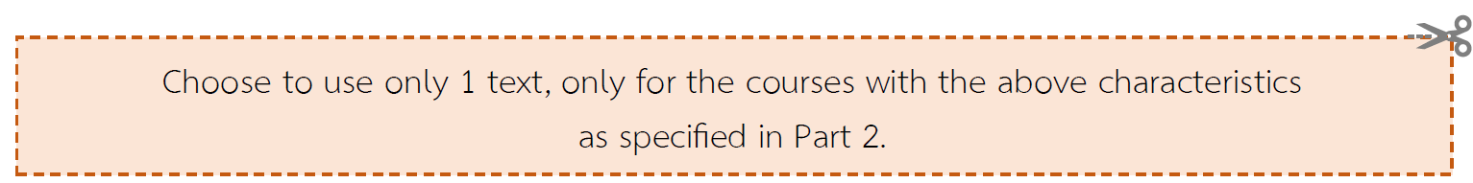
(International Programs) or (English Courses) or (Bilingual Programs)
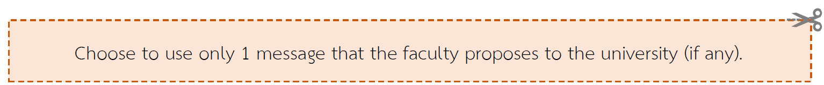
(5-year program)

New Curriculum B.E. ............ or Revised Curriculum B.E. .............


Department/Division...........................
Faculty or School.................................................
King Mongkut's University of Technology Thonburi

Table of Contents

Components |  |  |  | Page
Part 1 Executive Summary |  |  |  | 5
Part 2 Program Design and Concept |  |  |  | 8
 | 2.1) | Rationale for Opening or Revising the Program and Processes Involved in Defining the Concept of the Program. |  | 8
 |  | 2.1.1) |   Stakeholder Requirements Gathering Processes and the Conversion of Voice of Customer (VOC) to Voice of Process (VOP) for Opening or Revising the Program. | 8
 |  | 2.1.2) | External Environment Analysis | 10
 |  | 2.1.3) | Internal Environment Analysis | 13
 | 2.2) | Overall Product Concept |  | 14
 |  | 2.2.1) | Summary table of Issues from the Exploration and Stakeholder Analysis in topic 2.1 brings to the conclusion of the program design concept (Product concept). | 14
 |  | 2.2.2) | Strength and Competitive Edge | 15
 | 2.3) | Details of the Program Design |  | 15
 |  | 2.3.1) | Determination of Program Learning Outcomes (PLOs) | 15
 |  | 2.3.2) | Design Concept for Program Structure and Courses | 21
 |  | 2.3.3) | Design Concept for Teaching and Learning approach, Measurement and Assessment approach of Learning Outcomes | 27
 |  | 2.3.4) | Design Concept for Learning Supports | 36
 |  | 2.3.5) | Program Development Mechanism for Quality Assurance | 41
Part 3 Program Specification |  |  |  | 56
 | 3.1) | Program Code |  | 56
 | 3.2) | Program Name |  | 56
 | 3.3) | Degree Title and Field of Study |  | 56
 | 3.4) | Major (if any) |  | 56
 | 3.5) | Total Credit Hours |  | 57
 | 3.6) | Program Degree Level Type |  | 57
 | 3.7) | Program Type |  | 57
 | 3.8) | International Standard Classification of Education, ISCED |  | 58
 | 3.9) | Language of Instruction |  | 58
 | 3.10) | Collaboration with other Institutions (If any) |  | 59
 | 3.11) | Conferring Degrees |  | 59

Course Details (continued)

Components |  |  |  | Page
 | 3.12) | Location of Instruction |  | 59
 | 3.13) | Dates and Time of Instruction |  | 60
 | 3.14) | Educational Management and Educational System |  | 60
 | 3.15) | Full Name, Academic Rank and Educational Qualifications of the Program Responsible Faculty Members |  | 60
 | 3.16) | Full Name, Academic Rank and Educational Qualifications of the Program Faculty Members |  | 61
 | 3.17) | Qualifications of Prospective Students |  | 61
 | 3.18) | Program Status and Program Consideration/Approval |  | 62
 | 3.19) | Preparedness for Publication of a High-quality, Standardized Program |  | 63
 | 3.20) | Career Opportunities of the Graduates |  | 63
Part 4 Appendix |  |  |  | 64
 | Appendix A |  | Opinions of the External Experts and Program Responses | 65
 | Appendix B |  | Unit of Learning Descriptions | 66
 | Appendix B1 |  | Unit of Learning Descriptions: General Education / Basic Engineering / Basic Science and Mathematics | 66
 | Appendix B2 |  | Unit of Learning Descriptions of the subjects in the course | 67
 | Appendix(B2.1) |  | Unit of Learning Descriptions: Course | 67
 | Appendix(B2.2) |  | Unit of Learning Descriptions: Learning Pathways and OBEM | 67
 |  |  | a) OBEM as part of a Learning Pathway | 69
 |  |  | b) OBEM is not part of a Learning Pathway | 71
 | Appendix C |  | Background of the Program Faculty Members and Supporting Staff | 72
 | Appendix C1 |  | Background of the Program Faculty Members | 72
 | Appendix C2 |  | Background of the Supporting Staff | 76
 | Appendix D |  | Appointment of the Program Development/ Revision Committee | 77
 | Appendix E |  | Regulations of KMUTT on Undergraduate/ Graduate Studies | 77
 | Appendix F |  | Collaboration with other Institutions (If any) | 77
 | Appendix G |  | Course Comparison between the Former Program and the Revised Program (Only for Revised Program) | 78

Part 1 Executive Summary

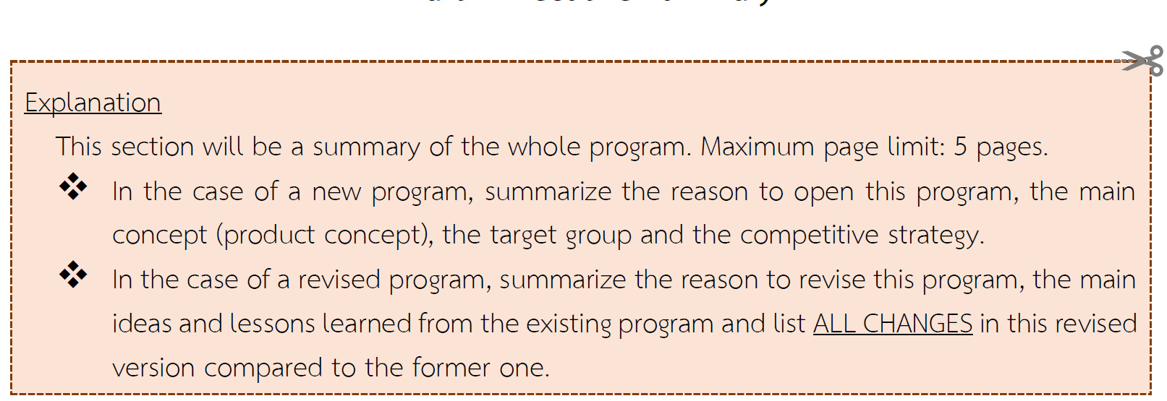
- The Rationale for Opening the New Program or Revising the Program
.....................................................................................................................................................................
2. The Product Concept of the New Program or the Main Concept of the Revised Program
.....................................................................................................................................................................
3. Issues changed from the former version of the program can be summarized as follows:
  - Revise the program learning outcomes (PLOs) corresponding to align with the needs of the key stakeholders.
Program Learning Outcomes of  The Former Version | Program Learning Outcomes of  The Revised Version
PLO1: ........................................................................  Sub-PLO1A: ...........................................................  Sub-PLO1B: ...........................................................  PLO2: ........................................................................ | PLO1: ......................................................................  Sub-PLO1A: ..........................................................  Sub-PLO1B: ..........................................................  PLO2: ......................................................................
The Program Learning Outcome (PLOs) are revised due to ........................................................................................................................................................................................................................................................................................................................................................................
  - Improve the Program structure as following:
[Take the table in section 2.3.2.1) Comparison the Program structure with the Notification of the Commission on Higher Education Standards (CHES) on B.E.2565 (Diploma / Bachelor's / Graduate Program)

Example  Category | Number of Credits |  |  |  | Difference in Number of Credits
Example  Category | Higher Ed. Criteria | professional council criteria or others. Specify ........  (if any)* | Former  Program  B.E. 25.... | Revised Program  B.E. 25... | Difference in Number of Credits
- General Education | ≥ 24 |  | 31 | 27 | - 4
- Specific Courses  - Subject Group ....................  - Subject Group ....................  - Subject Group.....................  - Subject Group..................... | ≥ 72 (4 years)  ≥ 90 (5 years)  (Choose one) |  | ....... | ...... | + 3
- Free Elective | ≥ 6
Total number of credits | ≥ 120  (4 years)  ≥ 150  (5 years)  (Choose one)

Explain the reasons of the changes. ..........................................................................................................................................................................
..........................................................................................................................................................................
For example,
Adjust courses in the program (Indicate course code, course name, credits and credit hours as examples below and explain supporting reasons)
  - Add (Number) specific courses in the science and mathematics
  - Reduce (Number) specific courses in the compulsory engineering subject group.
  - Increase WiL Plan
  - The curriculum defines a total of .......... Learning Pathways as follows:
Learning Pathway 1 : ........................ (Name of Pathway) ........................
This pathway comprises ………. OBEM courses, totaling ……….. credits.
Learning Outcomes of the Learning Pathway:
...............................................................................................................................................................
Learning Pathway 2 : ........................ (Name of Pathway) ........................
This pathway comprises ………. OBEM courses, totaling ……….. credits.
Learning Outcomes of the Learning Pathway:
...............................................................................................................................................................

For example
3.3) The curriculum defines a total of 1 Learning Pathway as follows:
Learning Pathway 1: Developing Data Management Processes for Big Data
This pathway comprises 9 OBEM courses, totaling 9 credits.
Learning Outcomes of the Learning Pathway:
Upon completion of this Learning Pathway, learners will be able to create data management processes for Big Data by utilizing Docker & Kubernetes to manage data infrastructure, enabling support for analytical and business operations

  - Other issues
...........................................................................................................................................................................
...........................................................................................................................................................................
For example ,
3.4) Improve the teaching and learning approaches
3.5) Increase / decrease the student admission plan
3.6) Increase the tuition fee or other specific fees
Etc.
Part 2 Program Design and Concept

2.1) Rationale for Opening or Revising the Program and Processes Involved in Defining the Concept of the Program.
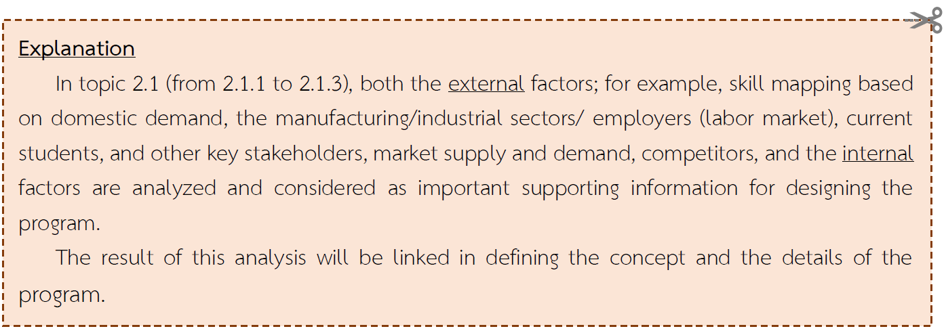

2.1.1) Stakeholder Requirements Gathering Processes and the Conversion of Voice of Customer (VOC) to Voice of Process (VOP) for Opening or Revising the Program.
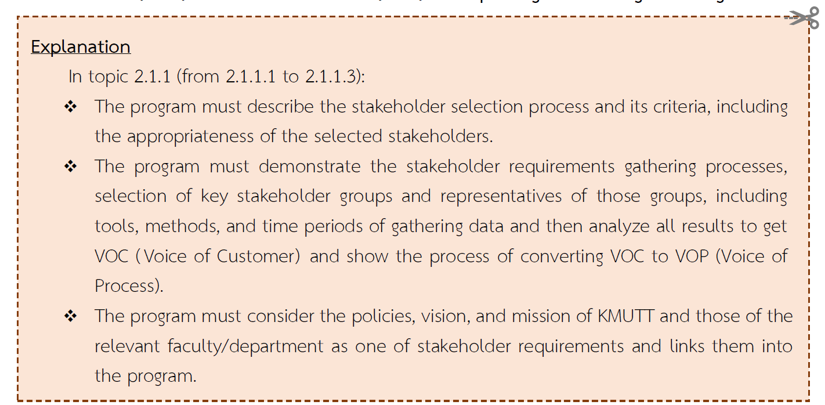
2.1.1.1) Exploration of Labor Market Needs
..........................................................................................................................................................................................................................................................................................................................................................
2.1.1.2) Exploration of Current Students Needs
..........................................................................................................................................................................................................................................................................................................................................................

2.1.1.3) Exploration of the Needs of other Stakeholder Groups; for example, Prospective Students, Alumni, Academic Staff, Supporting Staff, Parents, etc.
..........................................................................................................................................................................................................................................................................................................................................................
After gathering all the information above, key stakeholder requirements can be summarized as shown in Table ………..
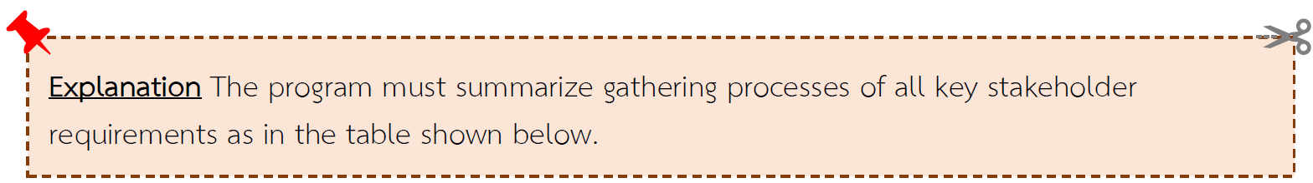

Key Stakeholders | Time period | Methods | Survey Issues | Results as Requirements
The University (University Council) |  | Gather from the university documents,  - university’s strategic plan  - KMUTT student QF, etc. | - KMUTT students/ graduates attributes  - Vision, mission and policy | - KMUTT graduates require leadership skills, communication capability, and good presentation skills
Academic Staff  (Instructors, Academic advisors, University supervisors for internship, Mentors/ Trainers in Company or Factory) | Before, during, and after each semester | Meeting / Seminar | CLOs, Course Content, Teaching methods, Problems found in classes | Using interesting teaching techniques and new technologies in teaching will be advantageous for students.
Alumni  (Graduated 1-2 years ago)  (Graduated 3-4 year ago)  (Graduated more than 5 years) | September – November 2022 | - Questionnaire  - Interview  - - Alumni Seminar | Nature of work and job assigned, Knowledge application in works,  New technology tools, Problems at work | - Ability to adapt themselves to technology disruption is needed.
Learner | ..................................  .................................. | ..................................  - .................................. | ..................................  .................................. | ..................................  ..................................
Employer | ..................................  .................................. | ..................................  .................................. | ..................................  .................................. | ..................................  ..................................
Please fill in the information of all stakeholder groups according to the actual exploration needs of each group.

2.1.2) External Environment Analysis
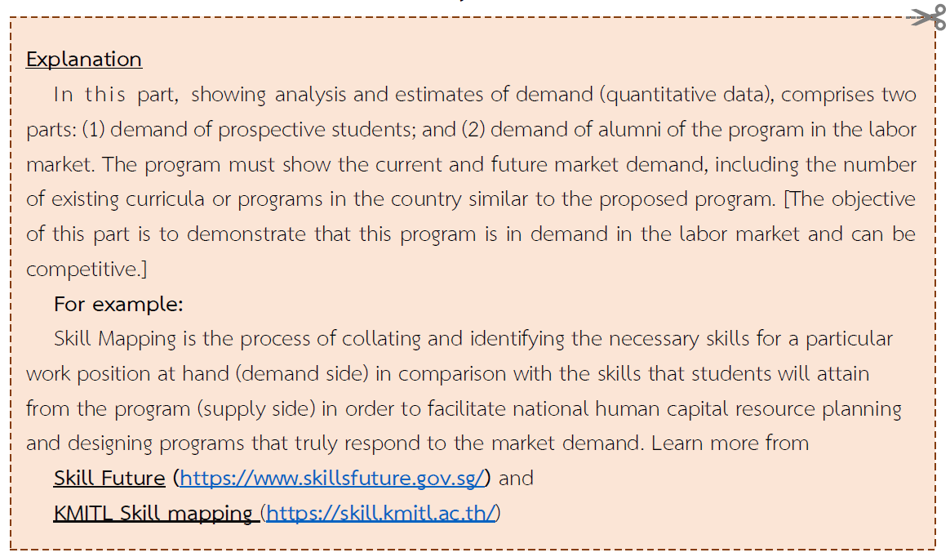

2.1.2.1) Analysis of Demand and Supply in Labor Market (Both Quantitative Data)
..........................................................................................................................................................................................................................................................................................................................................................

2.1.2.2) Competitive Benchmarking Analysis
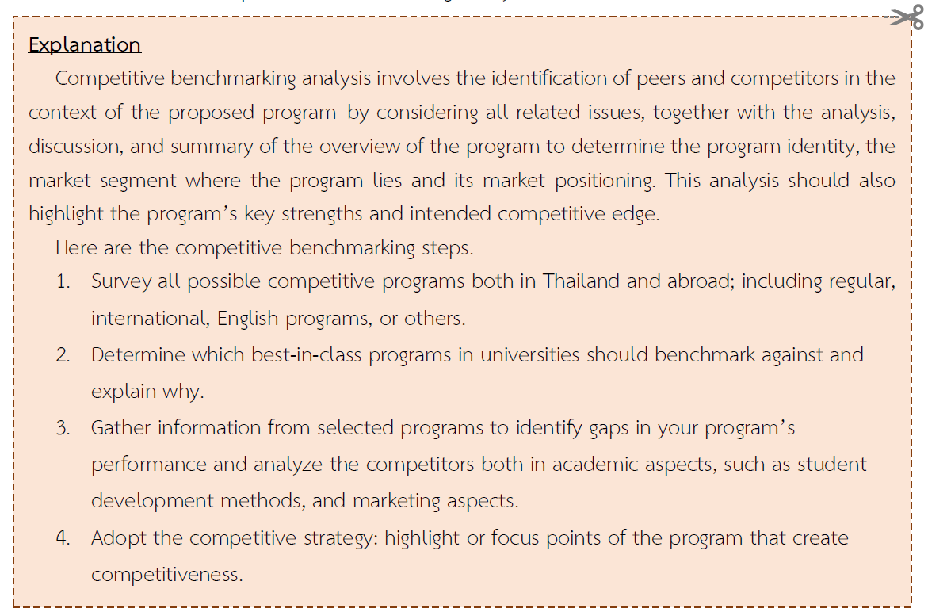
..........................................................................................................................................................................................................................................................................................................................................................

Examples (Guideline for preparation; can be adjusted according to the appropriateness of the program)
Issue | Programs and Universities
Issue | B.Eng. in Measurement Engineering (Continuous), KMITL | B.Eng. in Mechatronics and Automation Engineering, KMITL | B.Eng.in Robotics and Automation, KMUTNB | B.Sc. in Control Systems and Instrumentation Engineering, KMUTT (Current Course)
Years of Program | B.E. 2563 | B.E. 2563 | B.E. 2563 | B.E. 2563
Format of the Program | Bachelor's Degree 3 years (Continuous) | Bachelor's Degree 4 years | Bachelor's Degree 4 years | Bachelor's Degree 4 years
Languages | Thai | Thai | English | Thai
Total number of credits | 123 Credits | 149 Credits | 139 Credits | 143 Credits
Number of General Course Credits | 30 Credits | 30 Credits | 30 Credits | 31 Credits
Number of credits for specific courses | 87 Credits | 113 Credits | 103 Credits | 106 Credits
Number of credits for Free Elective Courses | 6 Credits | 6 Credits | 6 Credits | 6 Credits
Number of students according to the admission plan | 30 persons | 120 persons | 80 persons | 80 persons
Admission Qualified | Thai students and international students with good Thai language skills | Thai students and international students with good Thai language skills | Thai or international students who can use English | Thai and international students with good Thai language skills.
Internship/Cooperative Education | No compulsory internship courses. | Internship in the special semester of the 3rd academic year and can choose elective courses for cooperative internships. (6 credits) to go on an internship in the 1st semester of the 4th academic year | No compulsory internship courses. | two study plans: 1) regular internship in the special semester of the 3rd academic year and 2) a cooperative internship plan in the 1st semester of the 4th academic year.
Tuition fee per semester | 35,000 THB | 25,000 THB | 60,000 THB | Regular Plan: 20,937.50 THB,  Co-op Learning Plan: 42,000 THB
Academic Competence and Competence | - Graduates are able to apply knowledge and skills in automation design and development.  - Focus on self-learning, teamwork, communication, and professional ethics.  - Organize engineering and economics project management courses as compulsory courses. | - Graduates are able to apply knowledge and skills in automation design and development.  - Focus on System Integration to automate processes. | - Graduates are able to กesign and develop various types of robots using both pneumatic and hydraulic systems. | - Graduates are able to apply knowledge and skills in automation design and development.  - Focus on producing graduates who are ready to use and practical work.  - Learning emphasises on theory and practical experiences.  - Students can relate the course contents via the mini-projects with other necessary work skills added.  - Encourage students to keep pace with new technologies.

2.1.2.3) Other External Factors to be Considered (If any)
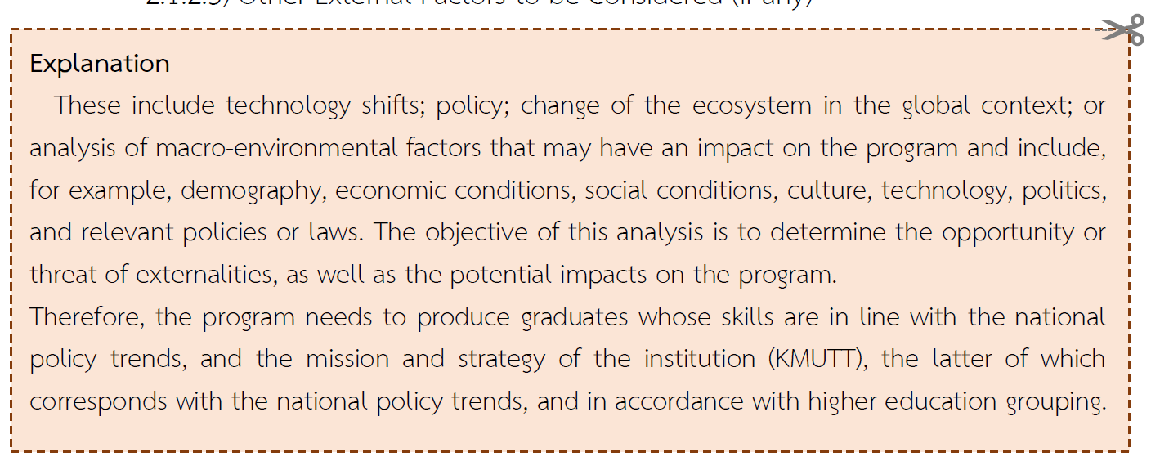
..........................................................................................................................................................................................................................................................................................................................................................

2.1.3) Internal Environment Analysis
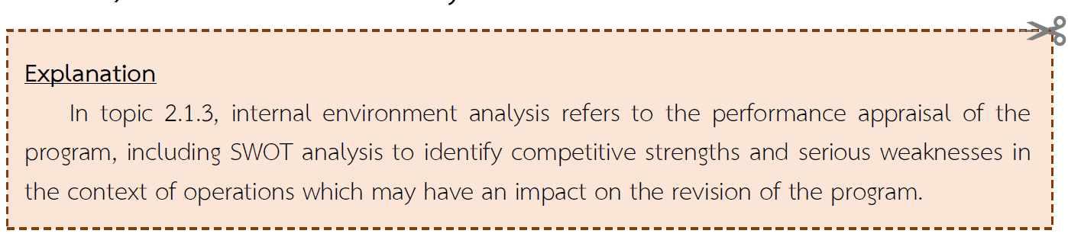
2.1.3.1) Performance Appraisal
..........................................................................................................................................................................................................................................................................................................................................................
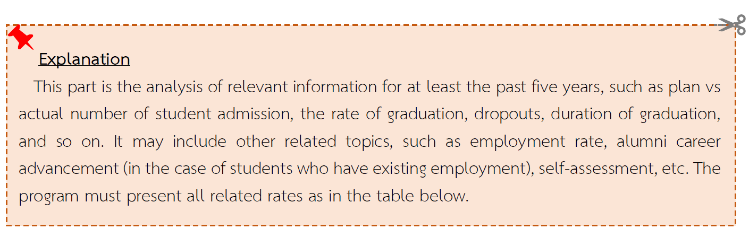

Table .... Number of students in the program from the academic year 20xx-20xx

Degree Title and Field of Study:
Student Admission Plan:
(In case of several admission plans, specify in remark)
Student ID | First-time Student (pers.) | Dropout  (pers.) | Left Behind  (pers.) | Graduate  (pers.) | Average Time to Graduate (year)
Code xx
Code xx
Code xx
Code xx
Code xx
Code 69
Remark: The data shown in the table (Row) represents the number of students in the same cohort.
2.1.3.2) Strengths Analysis
..........................................................................................................................................................................................................................................................................................................................................................

2.2) Overall Product Concept
2.2.1) Summary table of Issues from the Exploration and Stakeholder Analysis in topic 2.1 brings to the conclusion of the program design concept (Product concept).
Issues from the Data Analysis  in topic 2.1 | Improvement Issues | PLOs related
Issues from the Data Analysis  in topic 2.1 | Improvement Issues | PLO 1 |  | PLO 2 |  | PLO 3
Issues from the Data Analysis  in topic 2.1 | Improvement Issues | 1A | 1B | 2A | 2B | PLO 3
Group 1: Experts from both  Academic and Industrial  Sector  + .........................................................  + .........................................................  (Issue is taken from the summary in topic 2.1.) | Explain how has the program revised on these issues (in each bullet)?  ..............................................................
 |  | If any issue affects the determination of PLO, please specify which PLO is developed due to that revision, but if there is none (because it may only be an adjustment in teaching and learning management).
Group 2: Graduates student  during academic year  2015 – 2025  + ....................................................... | ............................................................... | / | / |  |  | /
+ ......................................................... | ................................................................ |  |  | /
+ ........................................................... | ................................................................ |  |  |  | /
Please enter the information according to the actual perform of the program completely.

2.2.2) Strength and Competitive Edge
.............................................................................................................................................................................
.......highlight or focus points of the program that create competitiveness to other programs ……
.............................................................................................................................................................................

2.3) Details of the Program Design
The overall product concept of the program (in topic 2.2) evolved into the details of the program, which are:
2.3.1) Determination of Program Learning Outcomes (PLOs)
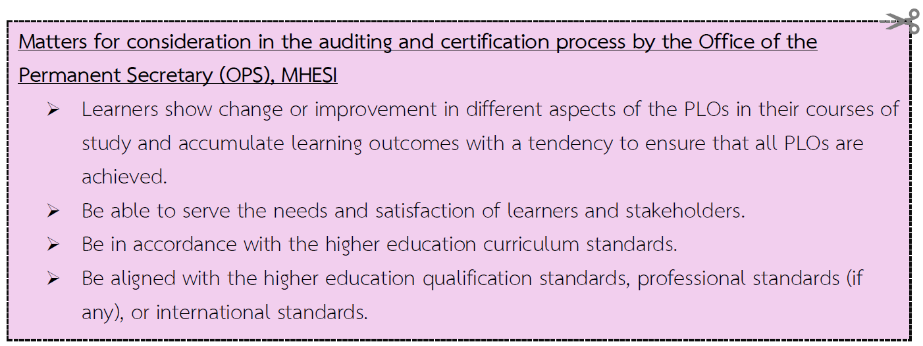

2.3.1.1) Philosophy, Importance and Objectives of the Program
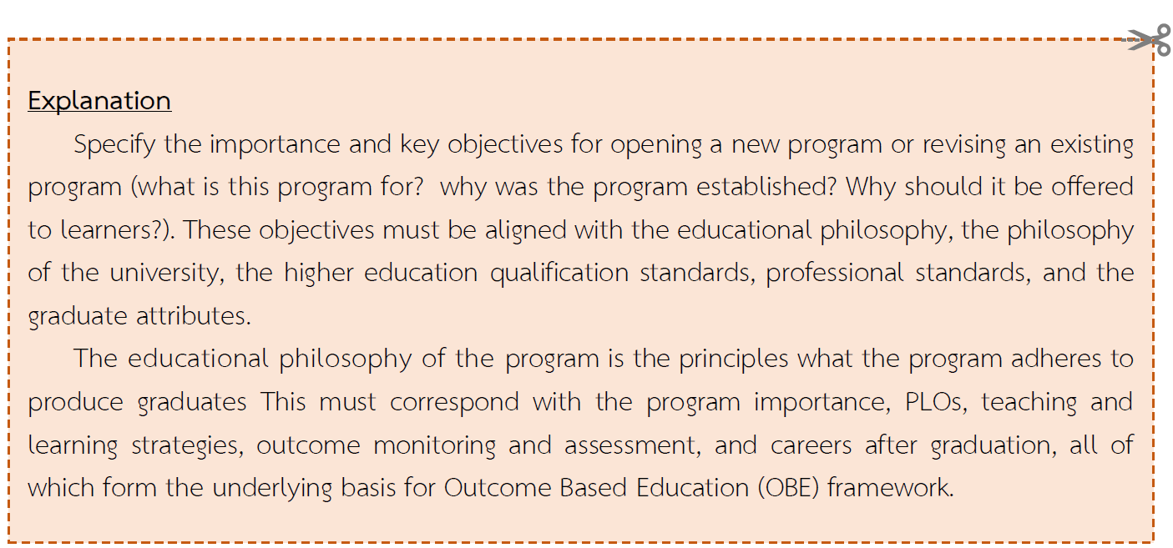
............................................................................................................................................................................. .............................................................................................................................................................................
2.3.1.1.1) Program Philosophy
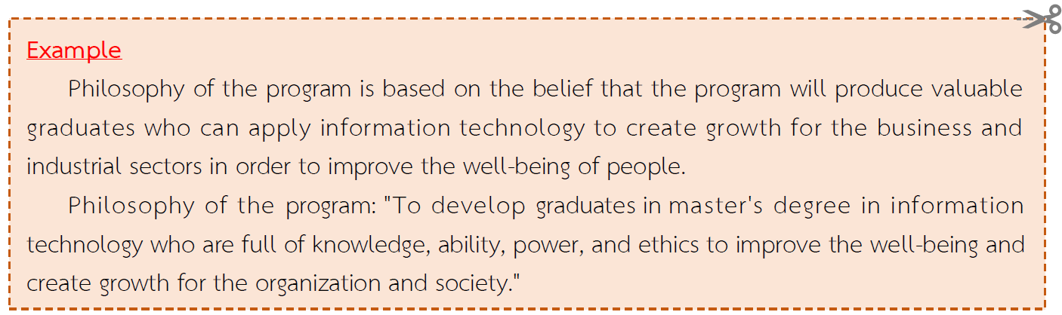

.............................................................................................................................................................................
.............................................................................................................................................................................
2.3.1.1.2) Importance of the Program
............................................................................................................................................................................. .............................................................................................................................................................................
2.3.1.1.3) Program Objectives
............................................................................................................................................................................. .............................................................................................................................................................................

2.3.1.2) Program Learning Outcomes; PLOs
PLO 1: ....................................................
Sub PLO 1A ……………………
Sub PLO 1B ……………………
PLO 2: .....................................................
Sub PLO 2A ……………………
Sub PLO 2B …………………..

2.3.1.3) The relationship between curriculum learning outcomes (PLOs), Graduate Attribute of King Mongkut's University of Technology Thonburi. (KMUTT student QF) and the Learning outcomes according to Thailand Qualification Framework (TQF).

Program Learning Outcomes (PLOs) |  | KMUTT Student QF |  |  |  |  |  |  |  |  |  | TQF Learning Outcomes
 |  | KMUTT’s citizenship |  |  | Knowledge | Professional | Thinking skill | Learning skill | Management skill | Communication skill | Leadership | 1. Knowledge |  |  | 2. Skills |  | 3. Ethics |  | 4. Character
 |  | Responsibility | Adaptability | Humanization |  |  |  |  |  |  |  | 1.1 ................... | 1.2 ................... | 1.3 ................... | 2.1 ................... | 2.2 ................... | 3.1 ................... | 3.2 ................... | 4.1 ................... | 4.2 ................... | 4.3 ...................
PLO 1: | ..................
Sub PLO 1A | ………………
Sub PLO 1B | ………………
PLO 2: | ..................
Sub PLO 2A | ………………
Sub PLO 2B | ………………

- Definition of the Desirable Graduate Attribute Framework of King Mongkut's University of Technology Thonburi (KMUTT-Student QF)

- Knowledge: having a deep academic knowledge base in the field of study and having extensive knowledge about the changes that have occurred and being able to apply knowledge to practice one's profession with expertise and in living a good life.
2) Professional Skills : the ability to translate knowledge into practice, have expertise in using professional tools and equipment, have the ability to apply technology to work, have the ability to guide and train others to be able to work and use various equipment.
3) Thinking skills : being creative, having a logical thinking system, knowing how to process information, brainstorming from different perspectives, being able to choose to use various thought patterns, and using them to solve problems and make decisions logically.
4) Learning Skills : knowing how to seek knowledge, seeing learning as occurring anywhere and anytime, which will help develop into a lifelong learner, able to learn through various forms of media, having a good system and method of thinking, and being able to distinguish and filter information obtained from learning appropriately.
5) Communication skills : having good skills in using Thai and English in listening, speaking, reading, and writing, being able to communicate with others correctly and appropriately, being able to convey and present work, and having good judgment in listening.
6) Management Skills: able to set goals, plan and execute effectively within resource constraints and on the basis of morality and ethics to achieve personal, organizational and social goals. Able to anticipate problems, impacts, and related factors, as well as have a positive attitude and the ability to prepare, prevent, and proactively resolve situations or problems.
7) Leadership : have confidence and value in themselves and others, have an understanding of the basics and needs of the team, be able to create a teamwork atmosphere, inspire and stimulate creativity, be aware of situations, opportunities, and challenges, and be able to seek/create ways to achieve a variety of goals. be to communicate and coordinate to create cooperation in team thinking and action, as well as being a good role model.
8) KMUTT’s Citizenship: Professionalism and Integrity, including adherence to the Code of Ethics to develop into a fully human being (Humanization)
a. Responsibilities: Be responsible for themselves, professionally, and society, be disciplined and punctual, care for the environment and the public., do not abandon work or shirk responsibility, be ready to accept and deal with the consequences of actions, both direct and indirect, respect the rules and regulations of the organization and society, as well as academic and professional ethics.
b. Adaptation: be flexible and not cling to any thing to the point of blocking oneself from others, and be prepared to accept changes without resisting them, but are ready to understand the necessity of the change that occurs.
c. Humanization: have an optimistic attitude, not look down on oneself and others, value humanity, care for environment and public, be able to live well with others, and know how to give, share, and sacrifice.

- Definition of Higher Education Qualification Framework (TQF) Learning Outcomes
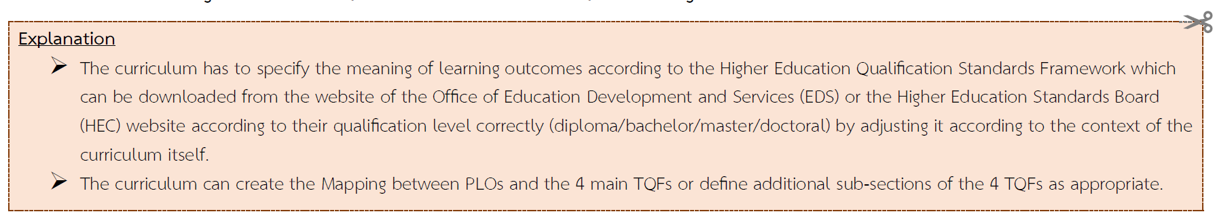

........................................................................................................................................................................................................................................................................................................................................................................................................................................................................................................................................................
............................................................................................................................................................................................................................................................................

References
- Office of Education Development and Services Website https://eds.kmutt.ac.th
- Higher Education Standards Board (HEC) website Notification of the Higher Education Standards Committee Re: Details of Learning Outcomes in accordance with Higher Education Qualification Standards B.E. 2565 (2022)

2.3.2) Design Concept for Program Structure and Courses
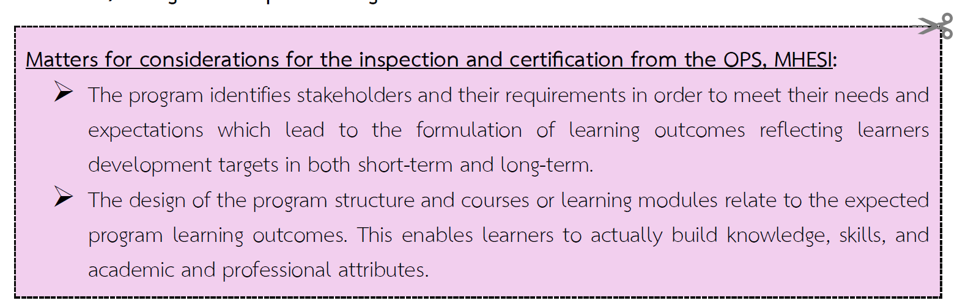

2.3.2.1) Comparison between the program structure and the Notification of the Higher Education Standards Committee for Diploma/ Bachelor/ Graduate Programs B.E. 2565 (2022)
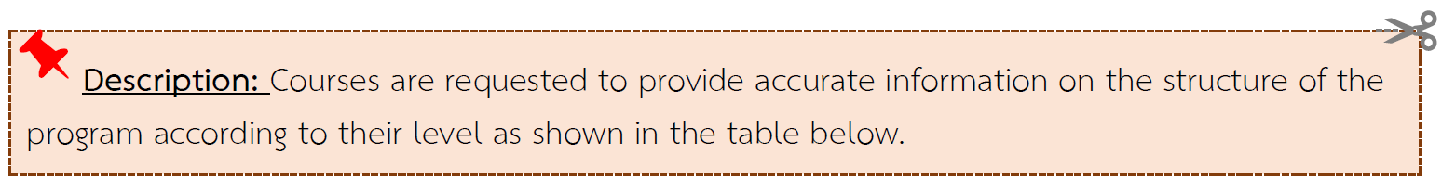

Diploma
Category | Number of Credits |  |  |  | Difference in Number of Credits
Category | Higher Ed. Criteria | Professional council criteria or others. Specify ........ (if any)* | Former Program B.E. 25….. | Revised Program B.E. 25….. | Difference in Number of Credits
- General Education | ≥ 24 |  | 31 | 27 | - 4
- Specific Courses  - Subject Group .................  - Subject Group .................  - Subject Group...................  - Subject Group................... | ≥ 30 |  | ....... | ...... | + 3
- Free Elective | ≥ 3
Total number of credits | ≥ 60
*Other criteria that the curriculum must consider such as the Council of Engineers, the Architect Council of Thailand, the Teachers Council of Thailand, etc. The number of credits in each subject must be determined in accordance with the above criteria.

Bachelor’s degree

Category | Number of Credits |  |  |  | Difference in Number of Credits
Category | Higher Ed. Criteria | Professional council criteria or others. Specify ........ (if any)* | Former Program B.E. 25….. | Revised Program B.E. 25….. | Difference in Number of Credits
1. General Education | ≥ 24 |  | 31 | 27 | - 4
2. Specific Courses  - Subject Group.........  - Subject Group.......  - Subject Group.......  - Subject Group....... | ≥ 72 (4 years)  ≥ 90 (5 years)  (Choose one) |  | ....... | ...... | + 3
3. Free Elective | ≥ 6
Total number of credits | ≥ 120 (4 years)  ≥ 150 (5 years)  (Choose one)
*Other criteria that the curriculum must consider such as the Council of Engineers, the Architect Council of Thailand, the Teachers Council of Thailand, etc. The number of credits in each subject must be determined in accordance with the above criteria..
Master’s Degree
Categories |  | Number of Credits |  |  |  | Difference in Number of Credits
 |  | Higher Ed. Criteria | Professional council criteria or others. Specify ........  (if any)* | Former Program  B.E. 25….. | Revised Program  B.E. 25….. | Difference in Number of Credits
 | Plan 1 (Academic)
Compulsory Courses |  | -
Elective Courses |  | -
Thesis |  | ≥ 12
Total number of credits |  | ≥ 36
 | Plan 2 (Professional)
Compulsory Courses |  | -
Elective Courses |  | -
Independent Study |  | ≥ 3 < 6
Total number of credits |  | ≥ 36
*Other criteria that the curriculum must consider such as the Council of Engineers, the Architect Council of Thailand, the Teachers Council of Thailand, etc. The number of credits in each subject must be determined in accordance with the above criteria..

Doctoral Degree
Categories |  | Number of Credits |  |  |  | Difference in Number of Credits
 |  | Higher Ed. Criteria | Professional council criteria or others. Specify ........ (if any)* | Former Program B.E. 25….. | Revised Program B.E. 25….. | Difference in Number of Credits
 | Plan 1.1 Applicants with a master's degree (48 credits thesis)
thesis |  | ≥ 48
Total number of credits |  | ≥ 48
 | Plan 1.2 Applicants with a bachelor's degree (72 credits thesis)
thesis |  | ≥ 72
Total number of credits |  | ≥ 72
 | Plan 2.1 Applicants with master's degree (36 credits thesis)
Compulsory Courses |  | ≥ 12
Elective Courses |  | ≥ 12
thesis |  | ≥ 36
Total number of credits |  | ≥ 48
 | Plan 2.2 Applicants with a bachelor's degree (48 credits thesis)
Compulsory Courses |  | ≥ 24
Elective Courses |  | ≥ 24
thesis |  | ≥ 48
Total number of credits |  | ≥ 72
*Other criteria that the curriculum must consider such as the Council of Engineers, the Architect Council of Thailand, the Teachers Council of Thailand, etc. The number of credits in each subject must be determined in accordance with the above criteria.

2.3.2.2) Details of the program structure and courses
a) Total number of credits in the program: ............... credits
b) Program Structure (by Category)
Examples of Undergraduate Program Structure
A. | General Education | ....... | credit
B. | Specific Courses | ....... | credit
 | - Basic Engineering | .......
 | - Basic Science and Mathematics | .......
 | - Compulsory ......... | .......
 | - Electives......... | .......
C. | Free Electives | ....... | credit

Example of Master's Program Structure
Plan 1 (Academic Plan)
A. | Compulsory Courses | ....... | credit
B. | Elective Courses | ....... | credit
C. | Thesis | ....... | credit
Plan 2 (Professional Plan)
A. | Compulsory Courses | ....... | credit
B. | Elective Courses | ....... | credit
C. | Independent Study | ....... | credit
Examples of Doctoral Program Structure
Plan 1.1 Applicants who have completed a master's degree (48 credits thesis)
A. | Thesis | ....... | credit
Plan 2.1 Applicants who have completed a master's degree (36 credits thesis)
A. | Compulsory Courses | ....... | credit
B. | Elective Courses | ....... | credit
C. | Thesis | ....... | credit
c) Courses
The course code consists of alphabets and numbers with the following meanings:
The course code is divided into (1) the case of Course, consisting of three alphabets and three digits and (2) the case of OBEM, consisting of three alphabets and five digits.
Alphabet Code
GEC stands for Compulsory Learning Unit in General Education.
GES stands for Elective Learning Unit in the General Education
LNG stands for Language and Communication subject group.
...... means ........................................ subject group.
...... means ........................................ subject group.

Course Number Code  (Only the XXX numeric code of this program is specified) | OBEM Course Number Code  (Only the XXXXX numeric code of this program is specified)
Hundreds digit refers to the level of the course  Numbers 1-4 refers to undergraduate course.  Number 5 refers to graduate course but  undergraduate students can choose  to study.  Number 6 and above refers to graduate course.  Tens digit refers to a group of subjects.  The number 0 refers to the ........................ subject group.  The number 1 refers to the ........................ subject group.  The number 2 refers to the ........................ subject group.  The number 3 refers to the ........................ subject group.  The number 4 refers to the ........................ subject group.  The number 5 refers to the ........................ subject group  The number 6 refers to the ........................ subject group  The number 7 refers to the ........................ subject group  The number 8 refers to the ........................ subject group  The number 9 refers to the ........................ subject group  The unit digit refers to the sequences of courses. | Digit 10,000 refers to the level of the course.  Numbers 1-4 refers to undergraduate course.  Number 5 refers to graduate course but  undergraduate students can choose to  study.  Number 6 and above refers to graduate course.  Thousands of numbers refers to a group of subjects.  The number 0 refers to the ....................... subject group.  The number 1 refers to the ....................... subject group.  The number 2 refers to the ....................... subject group.  The number 3 refers to the ....................... subject group.  The number 4 refers to the ....................... subject group.  The number 5 refers to the ........................ subject group  The number 6 refers to the ........................ subject group  The number 7 refers to the ........................ subject group  The number 8 refers to the ........................ subject group  The number 9 refers to the ........................ subject group  The hundreds digit refers to the sequence of the courses.  The tens digit number refers to the sequences of course in the OBEM type, which divides into two cases:  - OBEM without splitting from any course, use 00 (last two digits)  - OBEM with splitting from any course, use the number 01-09 respectively
Example  MTH 666  STD 111 | Example :  1) OBE101 Adjust to OBE10100  2) EDS101 Divided into EDS10101, EDS10102
A. Compulsory Course Category (Based on the Program Structure) .........credit
XXX xxx ……….Course Name (in English) .…… x(x-x-x)
(........... Course Name (in Thai) ............)
XXX xxxxx …….Module Name (in English) .…… x(x-x-x)
(........... Module Name (in Thai) ............)
GEC 11100 Humans and Ethics for Lifestyle 2(2-0-6)
(Man and Ethics of Living)
INT 60402 Information Governance 3(3-0-6)
(Data Governance)

B. Specific Course Category (Based on the Program Structure) .........credit
Please clearly state the conditions for choosing a course. For example, choose to take courses across subject groups, choose to study only one group of subjects, or choose extracurricular courses according to the approval of the program responsible faculty members, etc.
XXX xxx ………..Course Name (in English)....................... x(x-x-x) (........Course Name (in Thai)..........)
XXX xxxxx ……….Module Name (in English)....................... x(x-x-x) (........Module Name (in Thai).................)
C. Free Elective Courses 6 Credits
Learners can choose any courses offered at King Mongkut's University of Technology Thonburi.

d) Components Relating to Fieldwork Experience (specified) e.g. internship/ CWIE/Cooperate Education /Work Practice/WIL/others. For each category, the following topics must be specified:
d.1) Learning outcomes of field experience
Specify the course name and course learning outcomes as stated in the Appendix. B. Details of the Unit of Learning in the Curriculum.
d.2) Duration
d.3) Number of Credits
d.4) Preparation
Briefly describe the preparation of providing academic advice and support to learners. .
d.5) Learning Management
Explain the learning management of the course to achieve the learning outcomes of the prescribed course
d.6) Assessment Process
Explain the assessment process, including the mechanism for standard verification. .
d.7) List of cooperative field experience (if any)
Name of the agency/institution.

e) Specifications related to the Project or Research (if any)
e.1) Learning outcomes of projects or research
Specify the course name and course learning outcomes of the project or research to match those specified in Appendix B. Details of the Unit of Learning in the course.
e.2) Duration
e.3) Number of Credits
e.4) Preparation
Briefly describe the preparation of providing academic advice and support to learners.
e.5) Learning Management
Explain the learning management of the course in order to achieve the specified learning outcomes of the course. .
e.6) Assessment Process
Describe the assessment process, including the mechanism for standard verification .
2.3.3) Design Concept for Teaching and Learning approach, Measurement and Assessment approach of Learning Outcomes
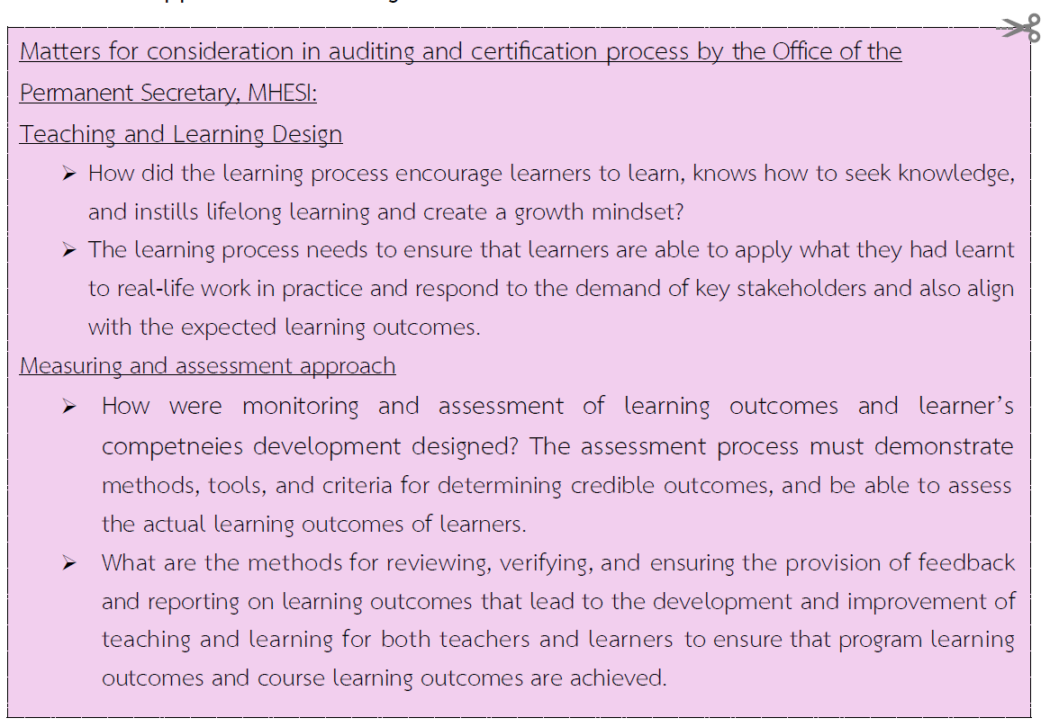

2.3.3.1) The teaching and learning process to enable learners achieve the program learning outcomes (PLOs) and course learning outcomes (CLOs).
- Study Plan
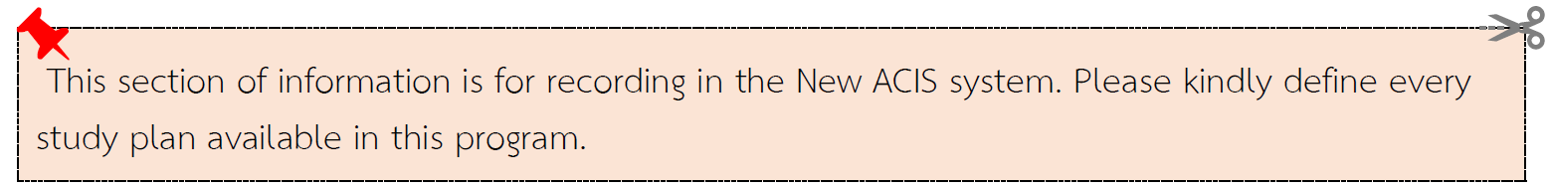

Study Plan.................
Year of Study...... Semester .......
XXX xxx | ………. Course Name ..............…… | credit | (L | P | S)
XXX xxx | ………. Course Name ..............……
XXX xxx | ………. Course Name ..............……
XXX xxxxxx | ………. Module Name ....................
XXX xxxxxx | ………. Module Name ....................
 | Total
 | Number of Hours/Week | = x
- Learning Pathway
............ Introduction, for example:"This Learning Pathway is an integral part of the courses within the program structure and the study plan. It is designed to align with the Learning Pathway to Career, ensuring that graduates possess the competencies required to perform effectively across diverse roles and responsibilities. Furthermore, it serves to enhance career advancement opportunities for graduates."………………………………………………………………………
…………………………………………………………………………………………………………………………………………………………..
Students are required to complete all courses within the designated learning pathway to achieve the intended learning outcomes. For non-degree learners, certification will be awarded upon completion of the pathway, in accordance with the program's regulations (Details are provided in Appendix B 2.2).
Recommendations for Establishing Learning Pathways
The establishment of a Learning Pathway is conducted in accordance with the University's policy as resolved in the Academic Council Meeting No. 3/2024 (March 11, 2024). All newly developed curricula and revised curricula scheduled for implementation from the 1/2026 academic year onwards, are required to design at least one Learning Pathway. Doctoral degree programs and Master’s degree programs (Plan 1.1 - Research only) are exempt from this requirement.
- A Learning Pathway is required to include Outcome-Based Education Module (OBEM) courses totaling at least 9 credits. Each OBEM must define exactly one Learning Outcome. Furthermore, OBEM courses must be designed to develop student competencies, enabling learners to perform specific professional tasks or functions effectively.
- The Learning Pathway is designed for non-degree learners. Upon completion, learners will receive certification. Furthermore, the credits earned can be accumulated and are eligible for credit transfer toward a degree program in the future.
- Courses that should not be part of a Learning Pathway and should not be designed in an OBEM course include: 1. Thesis, 2. Seminar, 3. Special Topics, 4. Cooperative Education, 5. Project, 6. Internship, and 7. WIL (Work-Integrated Learning).

The curriculum establishes a total of .......... Learning Pathways as follows:
Learning Pathway 1: ........................ (Identify Name) ............................
Consists of .......... OBEM (totaling .......... credits).
Learning Pathway 2: ........................ (Identify Name) ............................
Consists of .......... OBEM (totaling .......... credits).
Learning Pathway 3: ........................ (Identify Name) ............................
Consists of .......... OBEM (totaling .......... credits).

Learning pathway Diagram
Recommendations for Developing the Learning Pathway Diagram:
- Identify the category for each OBEM course (e.g., Compulsory Course or Elective Course) and specify any course conditions, such as Prerequisites or Co-requisites, within the Learning Pathway. Appropriate symbols may be utilized as needed for clarity.
- Identify the Course Code, Course Title, Credits, and Semester/Year on the diagram. For undergraduate programs, these must be specified according to the study plan and optional for graduate levels.
- For multiple pathways with shared courses, use a single integrated diagram. Present the common courses as one sequence, then clearly show the branching for each specific pathway.

(Example)
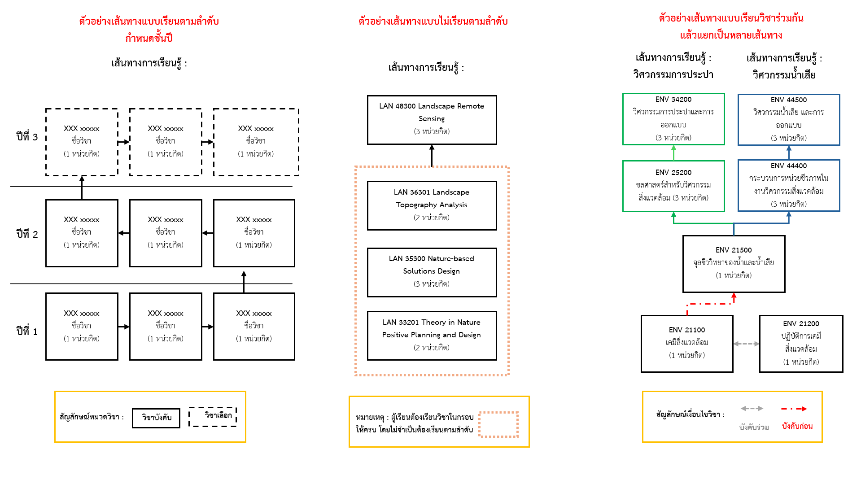

c) Describe the design of learning process, both in the classroom and extracurricular activities, to enhance students' Knowledge, Skills, competencies, Ethics, or Character
c.1) Encourage learners to learn, know how to seek knowledge, cultivate lifelong learning, and develop a growth mindset.
………………………………………………………………………………………………………………………………………………………………………………………………………………………………………………………
c.2) Promote and support artificial intelligence for learners (AI Literacy / AI & Digital Literacy)
………………………………………………………………………………………………………………………………………………………………………………………………………………………………………………………
c.3) Promote and support entrepreneurship for learners (Entrepreneurial Mindset and Skills)
………………………………………………………………………………………………………………………………………………………………………………………………………………………………………………………
c.4) Others……………………………
2.3.3.2) Assessment Approaches at Program-level and Course-level (PLOs) and CLOs)
a) The alignment of learning outcomes, teaching and learning approach, and assessment approach aims to develop learners to achieve the program learning (Constructive Alignment). This can be summarized as follows:
Table No. xxxxx …………………………………

Program Learning Outcomes (PLOs) | Teaching and Learning Approach | Assessment Approach
PLO1……………………………..  Sub PLO1A………………….  Sub PLO1B…………………. | ...................................................... | ......................................................
PLO2……………………………..  Sub PLO2A………………….  Sub PLO2B…………………. | ...................................................... | ......................................................
...................................................... | ...................................................... | ......................................................
- Stage Learning Outcomes (Stage-LOs) or Year Learning Outcomes (Year-LOs)
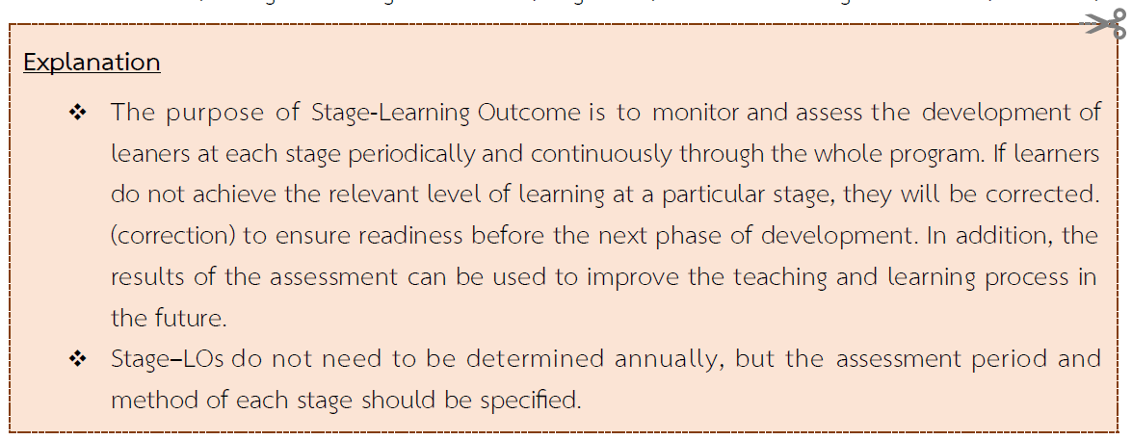
To ensure that learners have achieved the program learning outcomes, the program must set a control point or check point of learning outcomes to assessment the learning development of learners periodically and continuously. It can be summarized as follows:
b1) Stage-LO 1:
.............................................................................................................................................
b2) Time Period for Assessment
..................................................................................................................................................
b3) Assessment Methods
..................................................................................................................................................
b4) Criteria for Assessment
..................................................................................................................................................
Moreover, how is the process of tracking learners? And when learners are not able to pass or achieve the learning outcome, how is the curriculum’s management approach to assist them?
..................................................................................................................................................
..................................................................................................................................................
..................................................................................................................................................
..................................................................................................................................................

c) The relationship between program learning outcomes and course learning outcomes (PLOs-CLOs Curriculum Mapping)
c.1) Curriculum Mapping of the General Education Category for Undergraduate / the English Fundamentals course for Graduate students.
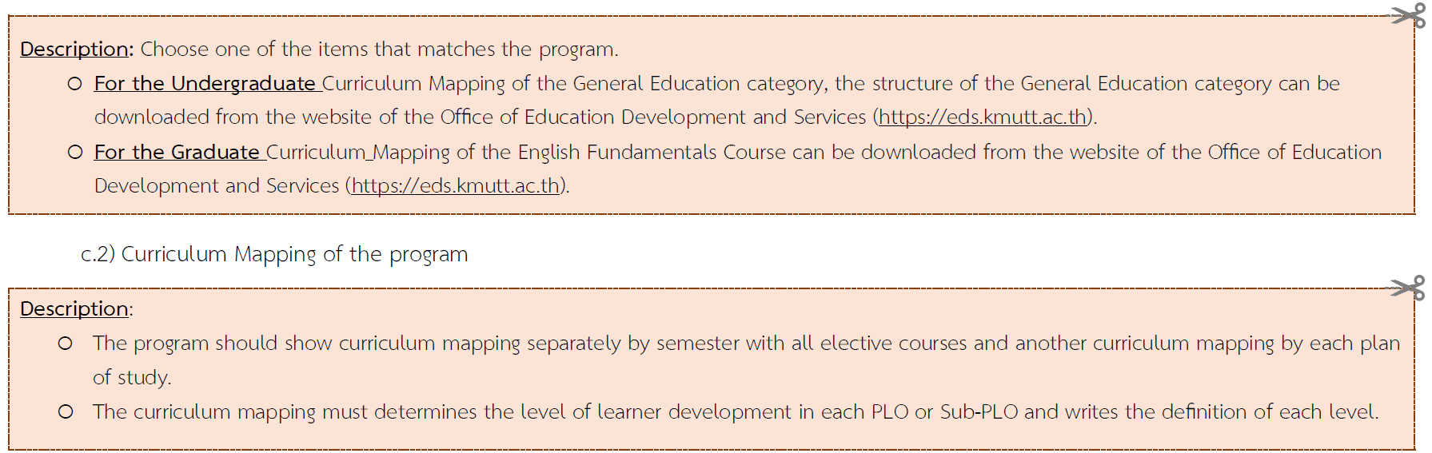

c.2) Curriculum Mapping of the program

Example 1 (As a guideline, it can be adjusted according to the curriculum)
Courses | PLO 1 |  |  | PLO 2 |  | PLO 3 |  | PLO 4
Courses | 1A | 1B | 1C | 2A | 2B | 3A | 3B | 4A | 4B
Plan 1 Academic Plan
Academic Year 1 Semester 1
MTH 111 Calculus 1 | I |  |  |  | I |  | I
SED 613 Statistics for Artificial Intelligence |  | R |  |  |  | I |  | I
INT 60401 Database Management |  |  | R | R |  |  |  | I | I
INT 60402 Governance Information |  | R |  |  | I | R
Academic Year 1 Semester 2
XXX xxx …………………………………. |  |  | R | I |  |  |  |  | I
XXX xxx …………………………………. |  |  | R |  |  | R
Academic Year 2 Semester 1
XXX xxx …………………………………. |  | M
Academic Year 2 Semester 2
XXX xxx …………………………………. | M |  |  |  | M |  |  | M
XXX xxx …………………………………. |  |  |  |  |  | M
Elective Courses
XXX xxx …………………………………. | I |  |  |  | I |  |  | R
XXX xxx …………………………………. |  |  | R |  |  | I
XXX xxx …………………………………. |  | I |  | I |  |  | I
Definition or meaning of each level
e.g. I = Introduced; indicate students are introduced to the outcome
R = Reinforced; indicate the outcome is reinforced and student afforded opportunities to practice
M = Mastery, indicate that students have had sufficient practice and can now demonstrate mastery

Example 2 (as a guideline for preparation, so it can be adjusted according to the curriculum)
Stage-LO | Courses | PLO 1 |  |  | PLO 2 |  | PLO 3 |  | PLO 4
Stage-LO | Courses | 1A | 1B | 1C | 2A | 2B | 3A | 3B | 4A | 4B
Stage LO 1 | Academic Year 1 Semester 1
Stage LO 1 | MTH 111 Calculus 1 | I |  | I |  | I | I | I
Stage LO 1 | SED 613 Statistics for Artificial Intelligence |  | I | R |  |  | R |  | I
Stage LO 1 | Academic Year 1 Semester 2
Stage LO 1 | INT 60401 Database Management |  |  | R | I |  |  |  |  | I
Stage LO 1 | XXX xxx ……………… (Check point)  .............................................................. |  |  | R  ....... |  |  | R  ........
Stage LO 1 | (if any) If the curriculum has any courses or activities defined. It is a point of examination for learners, such as Capstone Project, QE exam, thesis outline exam, etc.
Stage LO 2 | Academic Year 2 Semester 1
Stage LO 2 | INT 60402 Governance Information |  | R |  |  | R
Stage LO 2 | XXX xxx ……………… (Check point) |  |  |  |  | R
Stage LO 3 | Academic Year 2 Semester 2
Stage LO 3 | XXX xxx …………………………………. | R |  |  |  | M |  |  | M
Stage LO 3 | XXX xxx …………………………………. |  |  |  |  | M
Stage LO 3 | XXX xxx ……………… (Check point) |  |  | M |  | M | M
Elective Courses | XXX xxx ………………………………….
Elective Courses | XXX xxx ………………………………….
Definition or meaning of each level
e.g. I = Introduced; indicate students are introduced to the outcome
R = Reinforced; indicate the outcome is reinforced and student afforded opportunities to practice
M = Mastery, indicate that students have had sufficient practice and can now demonstrate mastery

d) Graduation criteria
- In accordance with the Notification of the Higher Education Standards Committee on Standards for Diploma/Bachelor's/Graduate Programs B.E. 2565 (2022) and in accordance with the Regulations of King Mongkut's University of Technology Thonburi. Regarding Undergraduate Education B.E. 2557 (2014) / Graduate Education B.E. 2568 (2025) or other amended regulations
- If there are other conditions other than the KMUTT regulations. Please specify more.
(e.g., Faculty announcements on work publication or English language requirements for graduation, etc.)
..........................................................................................................................................................................................................................................................................................................................................................

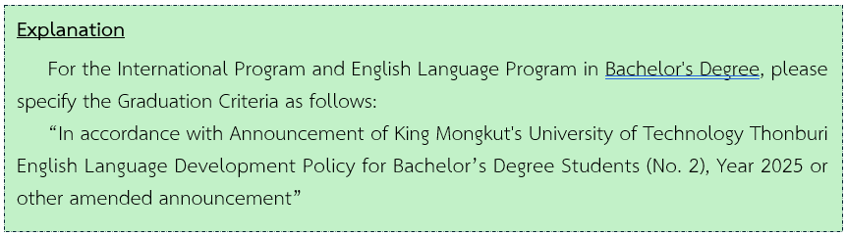

2.3.4) Design Concept for Learning Supports
2.3.4.1) Analysis of competency and readiness of academic staff and supporting staff
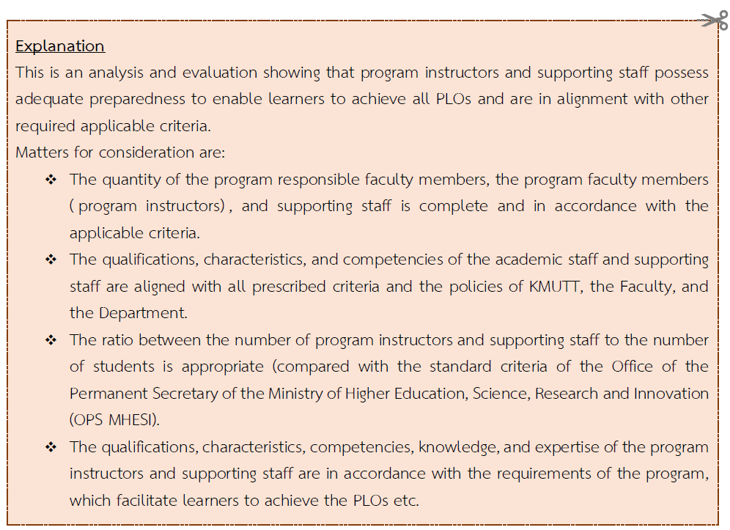
..........................................................................................................................................................................................................................................................................................................................................................

2.3.4.2) Guidelines for the development of academic staff and supporting staff

..........................................................................................................................................................................................................................................................................................................................................................
2.3.4.3) Facilities & Infrastructure and Student support services
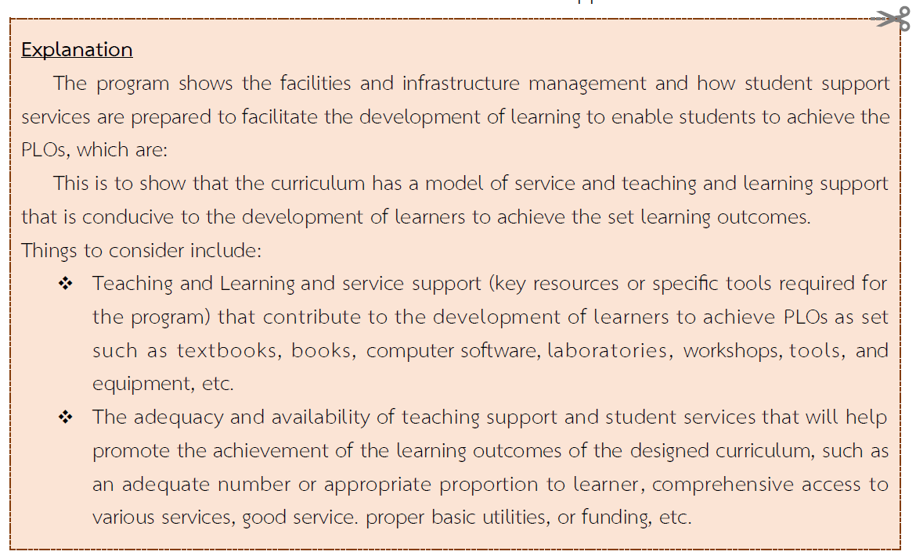
..........................................................................................................................................................................................................................................................................................................................................................

2.3.4.4) Incomes and Expenses of the program
a) 5-year plan for admissions and graduates.
Number of students based on the program plan (for consideration by the OPS)

Detail | 2027 | 2028 | 2029 | 2030 | 2031
Plan 1.1 for Master's Degree Candidates
Year 1 | 2 | 2 | 2 | 2 | 2
Year 2 | - | 2 | 2 | 2 | 2
Year 3 | - | - | 2 | 2 | 2
Total | 2 | 4 | 6 | 6 | 6
Plan 2.1 for Master's Degree Graduates
Year 1 | 2 | 2 | 2 | 2 | 2
Year 2 | - | 2 | 2 | 2 | 2
Year 3 | - | - | 2 | 2 | 2
Total | 2 | 4 | 6 | 6 | 6
Total for all plans | 4 | 8 | 12 | 12 | 12
Prospective graduates | - | - | 4 | 4 | 4

Total number of students of the program (for university consideration)
Detail | 2027 | 2028 | 2029 | 2030 | 2031
Plan 1.1 for Master's Degree Graduates
Year 1 | 2 | 2 | 2 | 2 | 2
Year 2 | 1 | 2 | 2 | 2 | 2
Year 3 | 1 | 1 | 2 | 2 | 2
Total | 4 | 5 | 6 | 6 | 6
Plan 2.1 for Master's Degree Graduates
Year 1 | 2 | 2 | 2 | 2 | 2
Year 2 | 1 | 2 | 2 | 2 | 2
Year 3 | 2 | 1 | 2 | 2 | 2
Total | 5 | 5 | 6 | 6 | 6
Total for all plans | 9 | 10 | 12 | 12 | 12
Prospective graduates | 3 | 2 | 4 | 4 | 4

- Tuition Plan
Tuition fee | 16,000 Baht/person/semester | 32,000 | Baht/person/year
Registration Fee | 1,800 Baht/credit | 42,300 | Baht/person/year
Tuition included |  | 74,300 | Baht/person/year
Tuition fees throughout the program |  | 148,600 | Baht/person

The details are as follows (for the purpose of preparing the announcement of the tuition fee of the program)
1. Students studying within the duration of the program
1.1 Regular semester
- Tuition Fee per semester ........... THB
- Course/Module Fee per credit ........... THB
- Thesis/independent study fee per credit THB
or - Tuition fee, flat rate per semester ........... THB
1.2 Special semester (choose 1 item)
No teaching and learning activities
Have teaching and learning activities (if necessary)
- Tuition fee per semester ........... THB
- Course/Module Fee per credit ........... THB
- thesis/independent study fee per credit ........... THB
or - Tuition fee, flat rate per semester ........... THB
2. Students studying over the time limit of the program (choose 1 item)
2.1 The same rate as item 1.
2.2 Collect other rates, as
2.2.1 Regular semester
- Tuition Fee per semester ........... THB
- Course/Module Fee per credit ........... THB
- Thesis/independent study fee per credit THB
or - Tuition fee, flat rate per semester ........... THB
2.2.2 Special semester (choose 1 item)
No teaching and learning activities
Have teaching and learning activities (if necessary)
- Tuition fee per semester ........... THB
- Course/Module Fee per credit ........... THB
- thesis/independent study fee per credit ........... THB
or - Tuition fee, flat rate per semester ........... THB
3. Other special fees (if any) per semester ........... THB
..........(Specify details and conditions for the special fees.) ..............
However, The tuition fee is subject to the announcement of the university.
c) Average expenses per student per 5 fiscal years .... THB

2.3.5) Program Development Mechanism for Quality Assurance
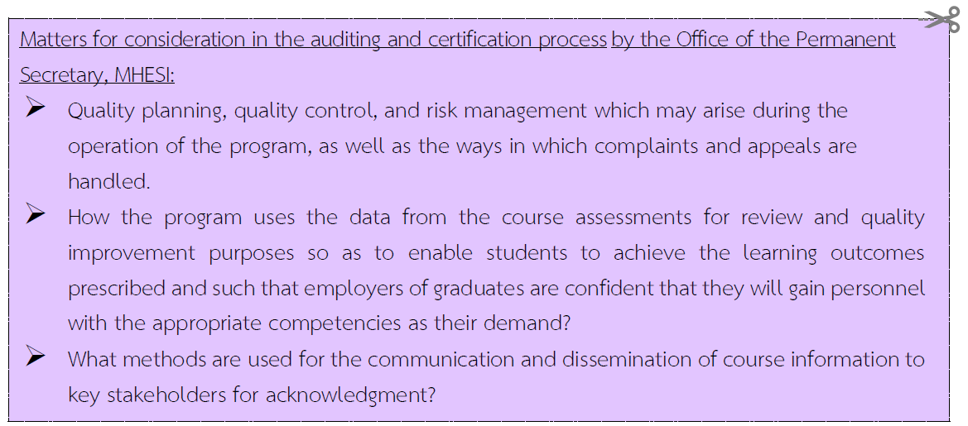

2.3.5.1) Quality Management Issues
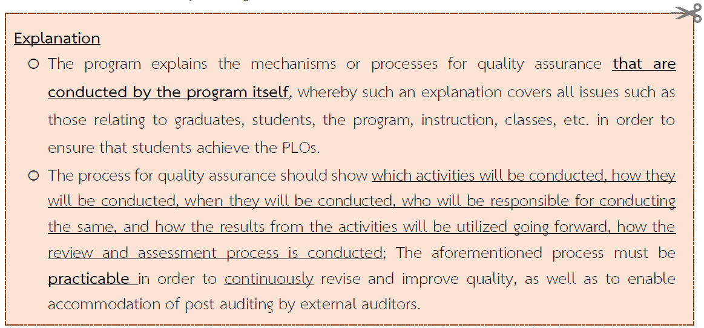

2.3.5.1(a) Educational Standard Criteria

..............................................................................................................................................................................
..............................................................................................................................................................................
Examples

Process | Educational Standard Criteria  For consumer protection, every program must comply with Educational Curriculum Standards (Component 1) of the Office of the Permanent Secretary, Ministry of Higher Education, Science, Research and Innovation (OPS MHESI) and every program must record information on component 1 in the Commission on Higher Education Quality Assessment online system (CHE QA online) every year. Therefore, the program will set up instructors and supporting staff as a working committee to supervise, monitor, and assess various operations of the program in accordance with the curriculum standards. This must be completed before the start of the semester. In addition, there will be an assessment by the faculty level committee at the end of the academic year on an annual basis and the results of the assessment which has been approved by the Faculty Committee will be reported to the university level and OPS MHESI, respectively. Recommendations from every level will be used as input to improve the program next round.
Control Points | - Compliance with curriculum standards  - Meet the criteria of professional councils such as the Council of Engineers Thailand, the Medical Council of Thailand, etc.
Person in charge | - Program responsible faculty members  - QMR (Quality Manager)  - The program responsible faculty members and quality assurance committee at the faculty level
Time period | At the end of semester
Inspectors | - Quality assurance committee at the faculty level  - Faculty Committee  - Associate Dean for Academic Affairs / Quality assurance
Monitoring and Evaluation process/ procedures | The person in charge of the curriculum is required to work together with the Associate Dean for Quality Assurance. The Assistant Dean for Quality Assurance verifies the accuracy of course data and lecturer information in the course, and evaluates the results of notifications and academic performance tracking, and finds ways to improve the implementation in the next year.

2.3.5.1.(b) Students
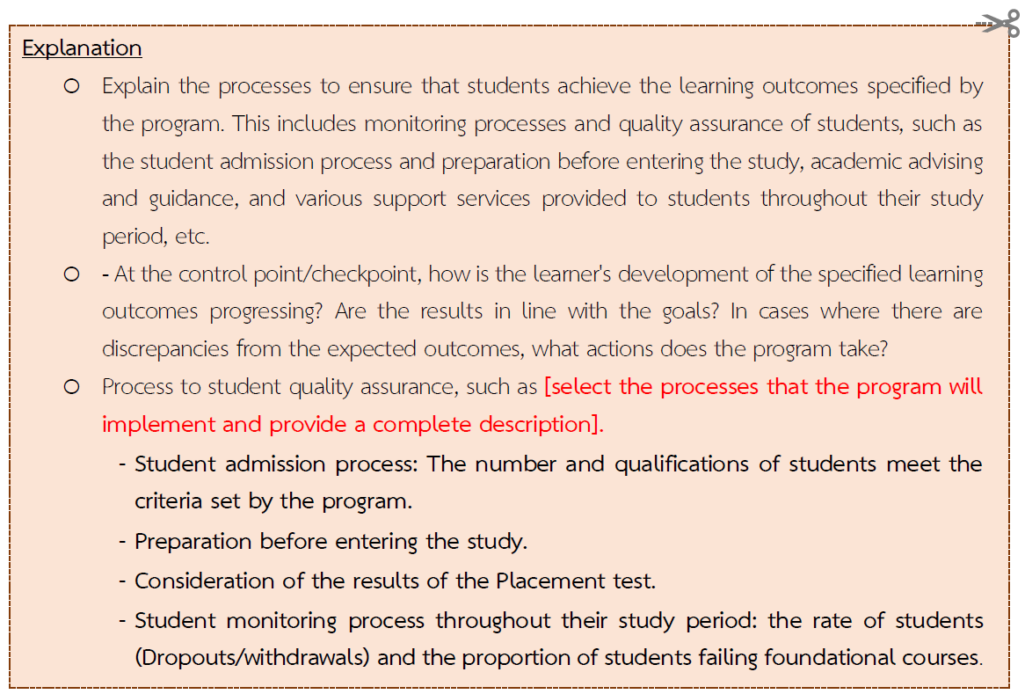
..........................................................................................................................................................................................................................................................................................................................................................
Writing Guidelines

Process: (1) Student Admissions
.................................................................................................................................................................................
.................................................................................................................................................................................
Control Points .....................................................................................................................................................
Person in Charge .......................................................................................................................................
Time period ..........................................................................................................................................................
Inspectors ...........................................................................................................................................................

Monitoring and Evaluation process/procedures
.................................................................................................................................................................................
.................................................................................................................................................................................
Process: (2) Preparation for learners before starting their studies.
..................................................................................................................................................................................
..................................................................................................................................................................................
Control Points......................................................................................................................................................
Responsible Person ..........................................................................................................................................
Person in Charge .................................................................................................................................................
Inspectors ............................................................................................................................................................
Monitoring and Evaluation process/procedures
.................................................................................................................................................................................
.................................................................................................................................................................................
Example
Process | - Student Admissions  The program conducts student admissions in accordance with the university's admission guidelines, following the timeline set by the faculty and university for each semester with the following steps:  1. Initial Preparation: Coordinate with the university's admissions office to disseminate information about the program and the student intake. Set the application period, admission criteria, and the number of students to be accepted in each round.  2. Preparation for Each Application Round: Receive applicant information from the university's admissions office, Prepare the interview system and establish the selection and interview committee members.  3. Execution in Each Application Round: Screen the qualifications of applicants (academic records, thesis outlines). Conduct interviews, announce eligible candidates for interviews, clarify selection guidelines to the interview committee, conduct interviews, and report the interview results to the university for both the Petchra Pra Jom Klao Scholarship program and the Direct Admission.  4. Conclusion: Summarize the admission data for each round, issues that arose, and suggestions for improvement in the next round.
Control Points | - Plan vs actual number of student admissions  - The number and qualifications of students are as specified by the program.
Person in charge | Faculty member and staff
Time period | Semester 1 from January to June  Semester 2 from July to December
Inspectors | Program Committee
Monitoring and Evaluation process/procedures | 1. Designate the program chair or concerned parties to monitor and verify each step of the process, especially at the checkpoints, and present findings to the program committee. Are the results in line with the goals? In cases where there are discrepancies from the expected outcomes, what actions does the program take?  2. After evaluating the interview results, the program chair or concerned parties should present the admission data for each round, address issues that arose, and discuss suggestions for improvement in the next round at the program committee meeting.

2.3.5.1.(c) Graduates
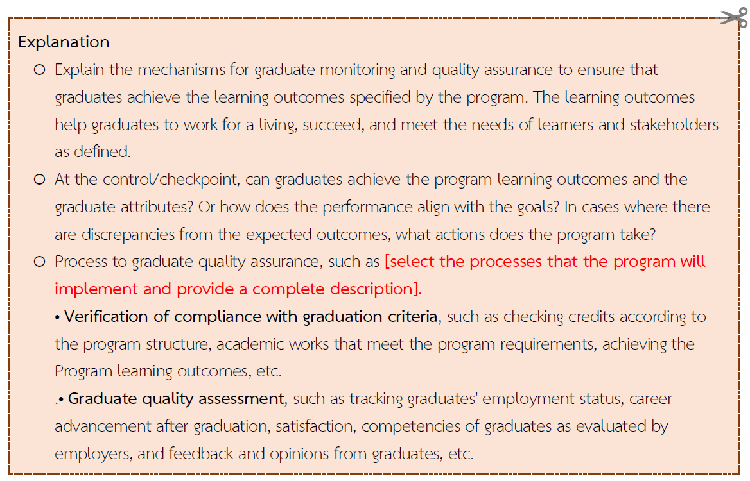

..........................................................................................................................................................................................................................................................................................................................................................

2.3.5.1.(d) Program, Teaching and Learning, Learner Assessment
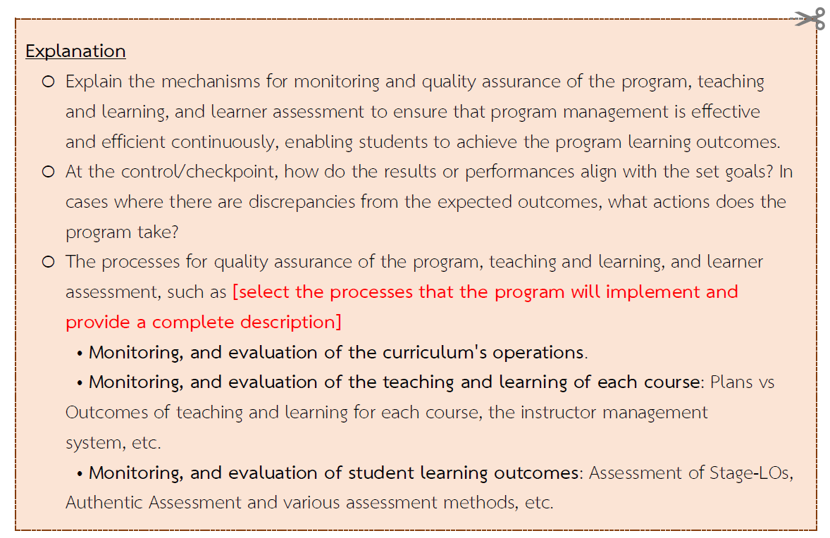
..........................................................................................................................................................................................................................................................................................................................................................
2.3.5.1.(e) Instructors
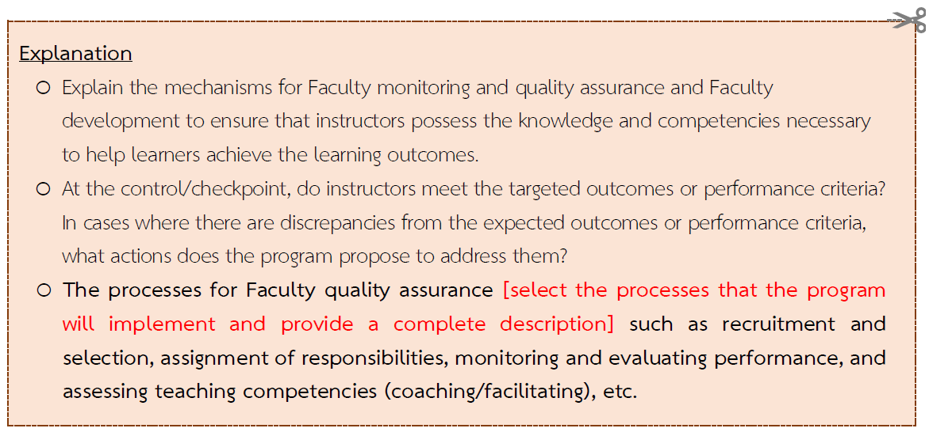

..........................................................................................................................................................................................................................................................................................................................................................

2.3.5.1.(f) Learning facilities and infrastructure
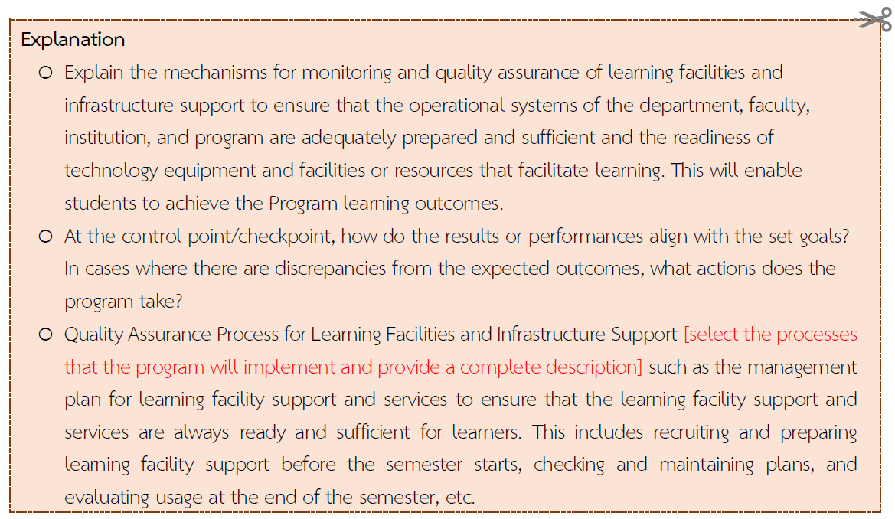
..........................................................................................................................................................................................................................................................................................................................................................
2.3.5.1.g) Others
..........................................................................................................................................................................................................................................................................................................................................................

Details of the program improvement and development process for quality assurance can be summarized in a Table .......

Issues | Control Points | Tools / Processes / Procedures / Approaches | Responsible Person | Examiner | Time Period
1. Regulatory standards | - Qualifications, attributes, and number of instructors  - Structure of the curriculum that includes all subjects in accordance with the standards set by the Engineering Council  - Ensure compliance with the criteria of professional councils (e.g., Engineering Council, Teacher Council) | - Announcement of the Higher Education Standards Committee regarding Standards Criteria for Undergraduate/ Graduate Curriculum B.E.2565 (2022)  - CHE-QA Online system  - Certificate for practicing controlled engineering professions  - Certificate of educational qualifications for professional practice from the Teacher Council  - Process for verification Component 1 and various criteria | - Program coordinator  - QMR (Quality Manager)  - Curriculum Committee or Academic Committee of the Department | - Quality Assurance Committee at the faculty level  - Faculty Committee  - Associate Dean for Academic Affairs / Quality Assurance | At the end of semester (twice a year, in general)
2. Students | - Enrollment plan vs. actual student intake  - Number and qualifications of students meet the program's requirements  - Student dropout/withdrawal rates  - Proportion of students failing basic courses (OBEM with grades lower than C)  - In the case of graduate students, OBEM grades lower than B | - Student Admission Process  - Preparatory Activities for Enrollment in the Program  - Placement Test Results  - Student Status and Academic Performance Tracking | - Program Faculty and Staff | - Program Director | Every Academic Year
3. Graduate | (1) Ensure compliance with graduation requirements:
3. Graduate | - Achievement of Program Learning Outcomes (PLOs) | - The process used to monitor and evaluate the Program Learning Outcomes (PLOs) established by the faculty or program  - LEB2 | - Year Advisors/Thesis Advisors  - Program Coordinator | - Faculty Committee  - Associate Dean for Academic Affairs/Graduate Studies  - Program Coordinator | Within 1month after the thesis/project defense exam
3. Graduate | - Completion of required credits according to the curriculum structure | Registration System (NewACIS System) | - Program Supporting Staff  - Graduate | - Registrar's Office  - Program Coordinator | When requesting for graduation
3. Graduate | - Student work, such as thesis, independent study (IS), and other requirements according to KMUTT graduate regulations and/or additional program-specific requirements | - Thesis Defense Exam  - Publications | - Thesis Advisor  - Thesis Examination Committee | - Program Coordinator | -
3. Graduate | (2) Graduate Quality Assessment:
3. Graduate | - Employment status of graduates in accordance with the needs of the program's stakeholders | - Questionnaire  - Interview | Program instructors and program supporting staff | - Program Coordinator | Every 6 months after graduation
3. Graduate | - Achievement of competencies (Skills or Competencies as specified) | - Skill Transcript | All relevant instructors | - Program Coordinator  - Dean | Upon graduation (closing transcript)
3. Graduate | - Career advancement after graduation | Questionnaire | Program instructors and program supporting staff | - Program Coordinator | Annually
3. Graduate | - Satisfaction, feedback, and the achievement of expectations of graduates regarding the program (self-assessment of whether their expectations were met) | Questionnaire  Focus Group  Interview | Program instructors and program supporting staff | - Program Coordinator | After graduation, at 5-year and 10-year intervals.
 | - Program Learning Outcomes (PLO) of graduates as assessed through the perspective of employers. | Interview with employers or supervisors | Every instructor involved | - Program Coordinator | Within 1-2 year after employment
4. Lecturer | Teaching Performance of the Instructor (Coaching/Facilitation) | - Instructor's PSF (Professional Standards Framework)  - Teaching Evaluation System for Instructors  - Class evaluation by Students | Program instructors and program supporting staff | - HRD/HRM  - Associate Dean for Administration | At least once a year
5. Curriculum / Teaching and Learning Approach/ Assessment | Assurance of Student Learning Outcomes by Stage-LOs | - As specified in the KMUTT Curriculum blueprint | - Program Coordinator | - Program Director in collaboration with Academic Advisors  Department/Faculty Academic Committee | - As specified in the KMUTT Curriculum blueprint
5. Curriculum / Teaching and Learning Approach/ Assessment | Soft skill (according to KMUTT Student QF) | - As specified in the KMUTT Curriculum blueprint | - Program Coordinator | - Program Director in collaboration with Academic Advisors  Department/Faculty Academic Committee | - As specified in the KMUTT Curriculum blueprint
5.1 Graduate Level | - Assessment of readiness to conduct research | - QE Exam  - Progress Exam  Comprehensive Exam (for non-IS/Thesis study plan) | - Thesis Committee  - Thesis Advisor | - Thesis Examination Committee  Program Director | - As specified in the KMUTT Curriculum blueprint
 | Research Competency Assessment | - Thesis Defense Exam | - Thesis Committee  - Thesis Advisor | - Thesis Examination Committee  Program Director | - As specified in the KMUTT Curriculum blueprint
6. Learning facilities and infrastructure  - Tools and equipment  - Place  - Technology  - Others | - Sufficient and readiness for learners  - Up-to-date materials | - Checklist  - Questionnaire regarding sufficient and readiness  - Productive and preventive maintenance plan  - Procurement process for learning facilities | Instructors, technicians, learning facilitators, teaching assistants | - Program Director | At the end of each semester (twice a year)
Note: The person responsible and the examiner must not be the same individual.

2.3.5.2) Risk Management
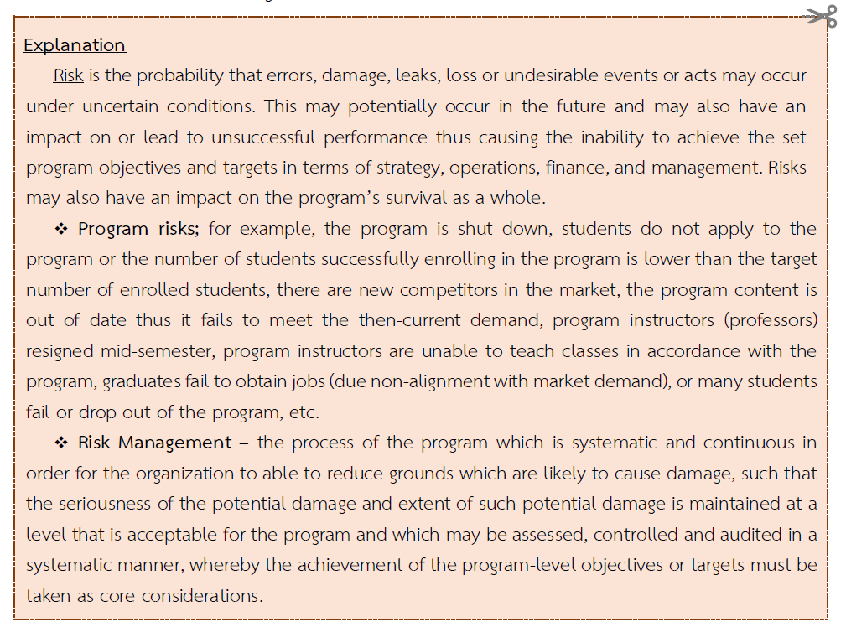

Example (as a guideline for preparation, it can be adjusted according to the suitability of the program)

Risk Issues | Risk Management Plans
- Rapid changes in new technologies | The program prepares by including a Special Topics course to respond to technological changes, ensuring that the program remains up-to-date and meets the demands of the labor market.
- Increased competition leading to fewer students being enrolled than planned or a reduced number of enrollments. | The program has activities to mitigate risks as follows:  (1) Proactive student recruitment activities, such as increasing promotional channels through social media, Open-house events both annually and for specific target groups, providing quotas through specialized camps, workshops, and hosting academic or skill competitions for target student groups, etc.  (2) Educational guidance activities for younger students by seniors
- ............................................. ............................................. | ......................................................................................................................................  ......................................................................................................................................

2.3.5.3) Complaints and Appeals Management
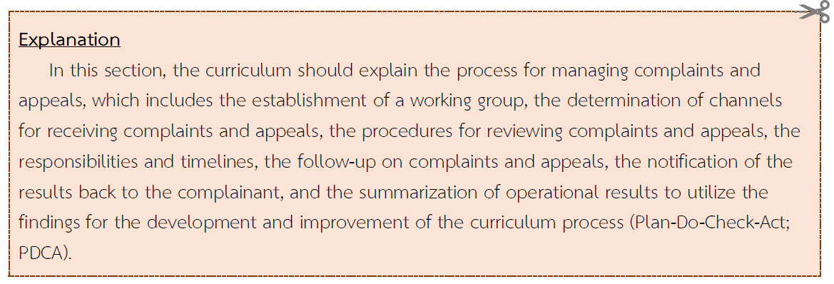
................................................................................................................................................................................................................................................................................................................................................
2.3.5.4) Stakeholder Engagement and Communication Plan
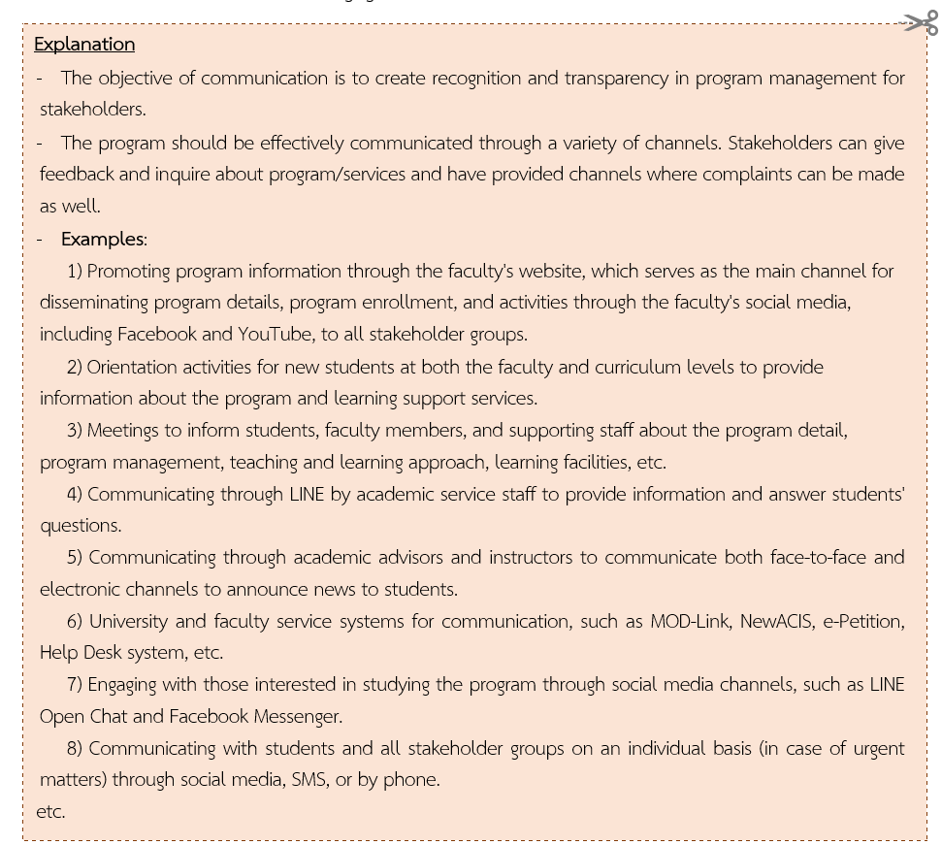
..........................................................................................................................................................................................................................................................................................................................................................
Part 3 Program Specification

  - Program Code: ............... Specify 14-digit code in CHECO system..............

  - Program Name
(Thai) : Program ........................ Major...................................................
(English) : …………………. of …………………. Program in ……………..................

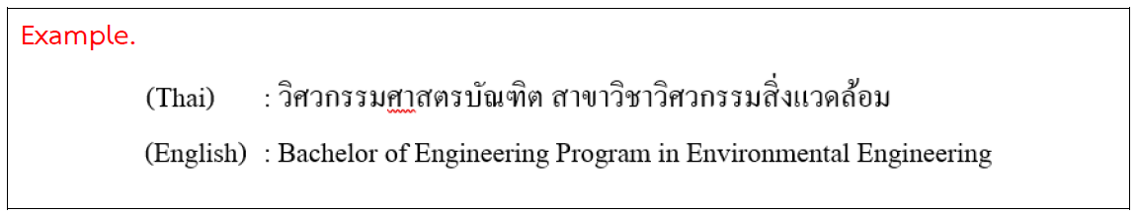
  - Degree Title and Field of Study (Thai/ English)

3.3.1 Full Name (Thai) : ……………………….. (……………………………………..) (English) : ……………………….. (……………………………………..)
3.3.2 Abbreviation (Thai) : ……………………….. (……………………………………..) (English) : ……………………….. (……………………………………..)
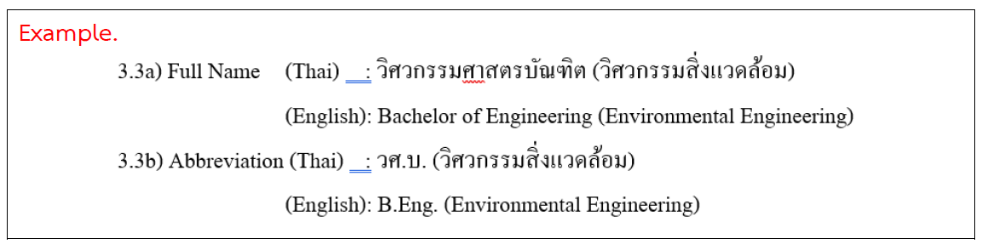

  - Major (if any):

- None
- Available which is/are (Specify) ................................................................
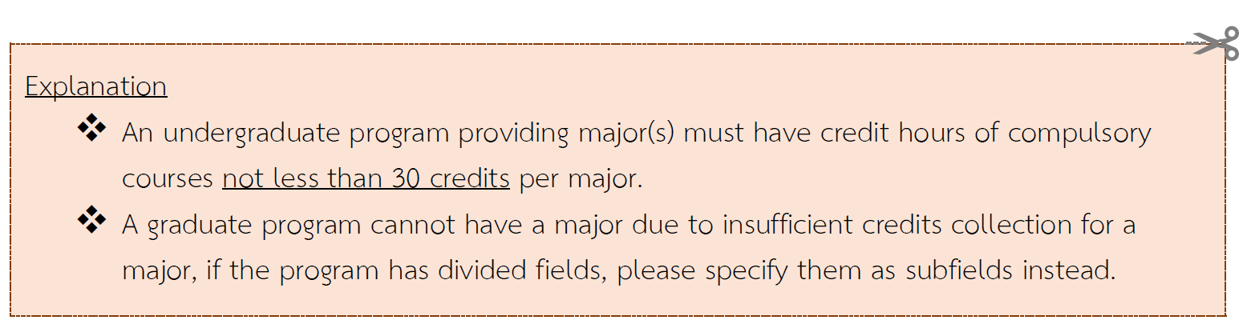

  - Total Credit Hours:
............. credit
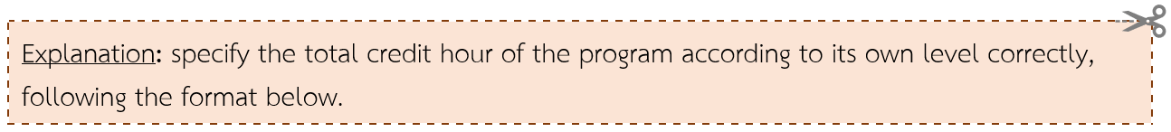

Bachelor’s Degree …….….. credit
Master's Degree
Plan 1 (Academic; a research-focused and thesis program) …......... credit
Plan 2 (Professional; a coursework-focused program with no thesis) …….….. credit
Doctoral Degree
Plan 1.1 Students who hold a master’s degree …….….. credit
plan 1.2 Students who hold a bachelor’s degree …….….. credit
plan 2.1 Students who hold a master’s degree …….….. credit
plan 2.2 Students who hold a bachelor’s degree …….….. credit

  - Program Degree Level Type:
4-Year or 5-Year Undergraduate (Bachelor’s) Program
2-Year Graduate (Master’s) Program under Plan ….. [Plan 1 (Academic) and/or
Plan 2 (Professional)]
3-Year Ph.D. Program under Plan .... (1.1/2.1) or 4-Year Ph.D. Program under Plan ......(1.2/2.2)

  - Program Type
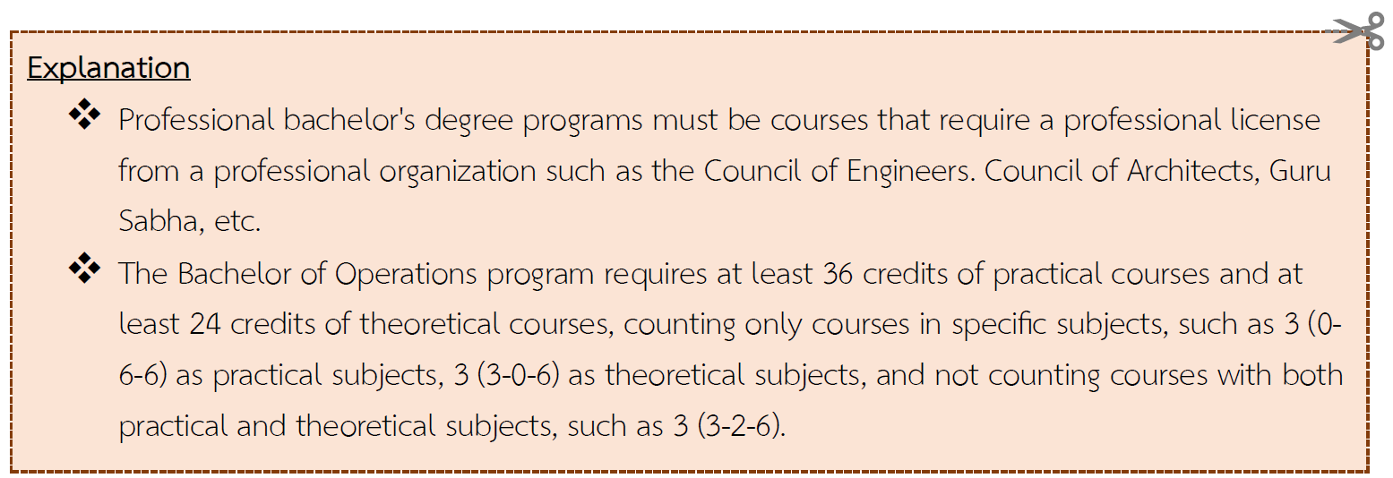

Bachelor's Degree (choose 1 type)
- Academic Bachelor’s Degree
- Professional Bachelor’s Degree
- Operations Bachelor’s Degree

Master's Degree
- Academic Master's Degree
- Professional Master's Degree
Doctoral Degree
- Academic Ph.D. Degree

  - International Standard Classification of Education, ISCED
1) Broad Field: …06 Information and Communication Technologies (ICTs)...
2) Narrow Field: …061 Information and Communication Technologies (ICTs)...
3) Detail Field: …0612 Database and network design and administration......

Explanation
Please specify all topics (1-3) completely and in more detail; for more information, see the ISCED 2013 classification document.
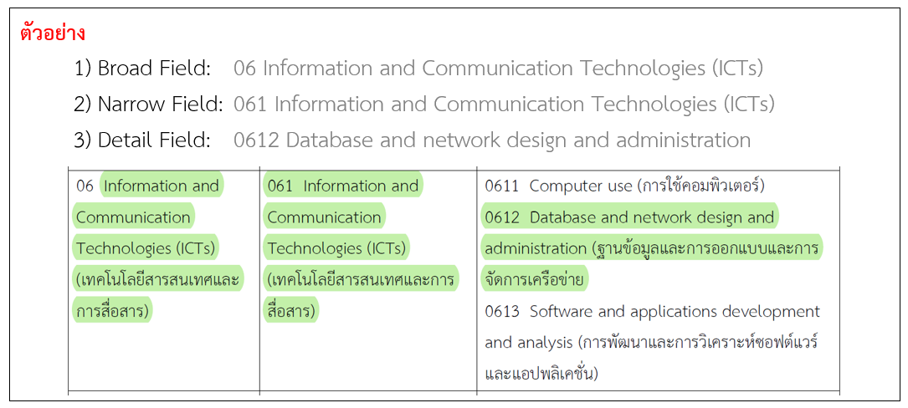

  - Language of Instruction
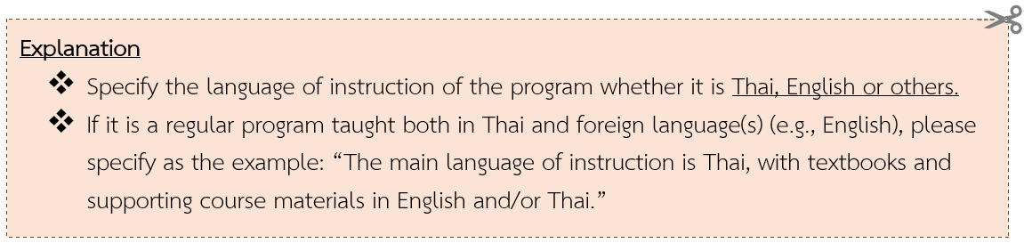

The language of instruction is ......... [Thai, English or other foreign languages (specify)] with textbooks and supporting course materials in......... [Thai, English or other foreign languages (specify)]

  - Collaboration with other Institutions (If any)
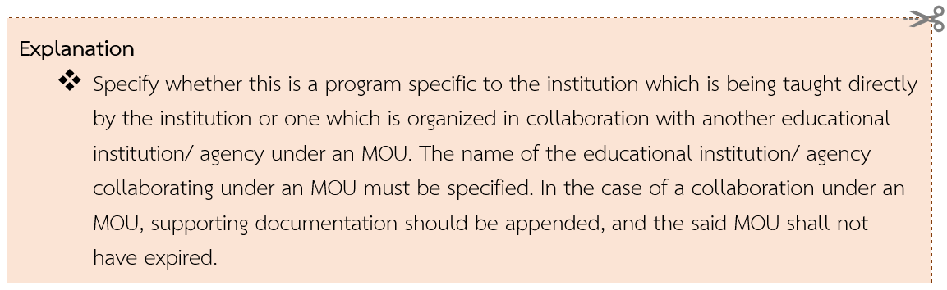

- A program specific to the institution which is being taught directly by the institution.
- A program which is organized in collaboration with another institution as follows:
- MOU-based collaboration: : .......................................................

  - Conferring Degrees
.......................................................................................
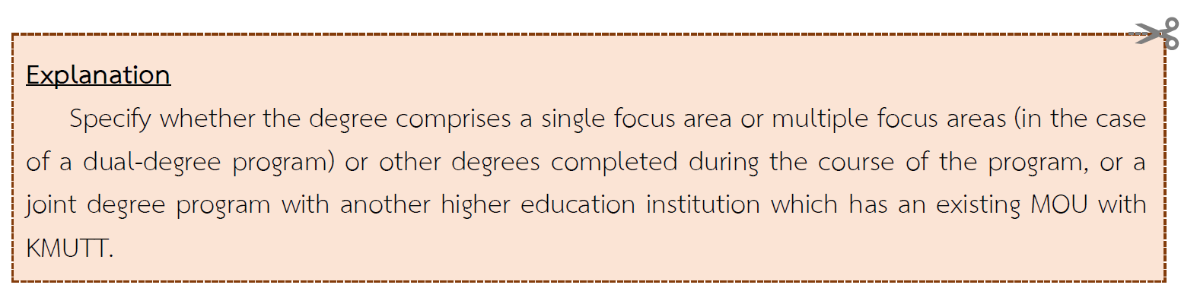

  - Location of Instruction

Department of..........................., Faculty of………………….
King Mongkut’s University of Technology Thonburi,
Bangmod Campus / Bangkhuntian Campus / Ratchaburi Learning Park

  - Dates and Time of Instruction
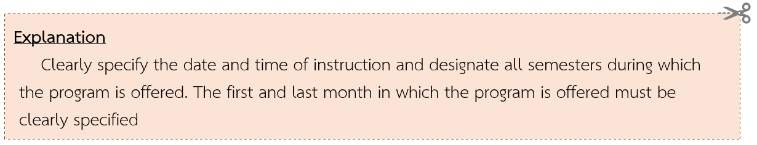

- Business hours (Mon – Fri, 08.30 am – 4.30 pm) and/or
- Outside of business hours (Mon – Fri, 6.00 pm – 8.00 pm and Sat – Sun, 09.00 am – 6.00 pm)
The date and time of instruction may be subject to change as appropriate.
Academic Calendar
Semester 1: August – December
Semester 2: January – May
Special Semester: June – July (if any)

  - Educational Management and Educational System
Education Management
The system divides each year of study into two semesters for full-time studies. Each semester has a duration of at least 15 weeks.
Education System
- The mode of instruction comprises in-person classroom settings and/or the use of electronic media.
- Others (Specify) ...................................................

  - Full Name, Academic Rank and Educational Qualifications of the Program Responsible Faculty Members
(Add the symbol * after the name of the program director)

No. | Full Name | Educational Qualifications (Field of Study),  Name of Institution, Country (Graduation Year)  (Organize by the highest level of qualification to Bachelor’s degree level of studies)
1 | Dr. Sombat Appropriate* | Ph.D. (Computer Science) University of Alabama, U.S.A. (2020)  M.Sc. (Computer Science) Vanderbilt University, U.S.A. (1999)  B.Sc. (Computer Science) Thammasat University, Thailand. (1991)
2
3
4
5

  - Full Name, Academic Rank and Educational Qualifications of the Program Faculty Members.
(Include the list of Program Responsible Faculty Members, along with their Professional Standards Framework (PSF) certifications (e.g., Thailand PSF, KMUTT PSF, UK PSF, or other relevant frameworks), if applicable.)

No. | Full Name | Educational Qualifications | Focus Areas  Related to the Program (Explain) | PSF Level/Status  (if any)
 | Name | Direct/ Related  (Specify whether they are direct or related to the program) | Specify only in cases related to the program of study or specific areas | Certified KMUTT PSF at Level 2 (Competent) for Learning Teaching and Support Learning
1 | Dr.Sombat Moesom | Direct | -
2 | Asst. Prof. Dr. Sudsuay Saendee | Related | The instructor has expertise in computer science and information technology, as well as communication and public relations, both in online media and media innovations, which aligns with the needs of the program.

  - Qualifications of Prospective Students

- Specify whether “Thai students” or “international students” or “Both Thai and international students” are eligible for enrolment.
- Specify the qualities and qualifications of the target students of the program, whereby the expected qualities and qualifications must be adequate to enable students to graduate in accordance with the program.
- Qualities and qualifications of prospective students may be separate based on each plan of study.

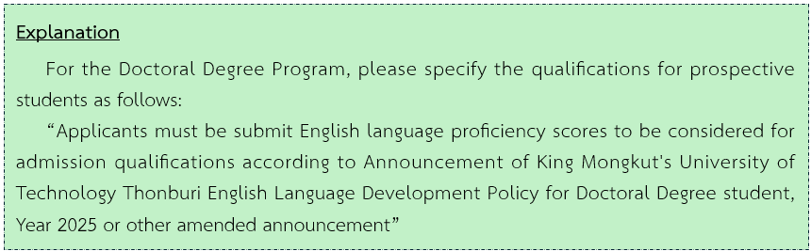

  - Program Status and Program Consideration/Approval
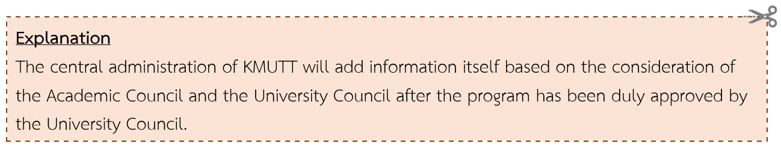

(Select one option and delete the others that are not relevant to the program.)

- New Program Scheduled to commence in (Month)............................. Year .......................
Semester................... Academic Year........................................
- Revised Program Scheduled to commence in (Month).......................... Year .......................
Semester................... Academic Year.......................................
- Instruction began since (Year)..........
[Specify the year in which the instruction of the program began for the first time.]
- Revised from (Degree Title) ............ Program in (Field of Study) ................. New Program/ Revised Program B.E. .........
[Specify the degree title, field of study and the year of the existing program prior to the revision.]
Considered by the Academic Council at Meeting No. ............/.............
Date................... Month............................. Year ......................
Approved by the University Council at Meeting No. .....................
Date................... Month............................. Year ......................

  - Preparedness for Publication of a High-quality, Standardized Program
Explanation
The publication period should have a duration equivalent to half of the duration of the program. For revised programs that will become effective in the semester 1/2027, the “year of publication” Should be designated as per the following guidelines:
- Bachelor’s Degree/ Undergraduate 4-Year Program = Academic Year 2028 or 5-year program = Academic Year 2029
- Master’s Degree/ Graduate 2-Year Program = Academic Year 2027
- PhD Program 3-5-year program = Academic Year 2028

The department is prepared to engage in the publication of a high-quality, standardized program in accordance with the Standards for Higher Education Qualifications B.E. 2565 (2022) in Academic Year ..........

  - Career Opportunities of the Graduates
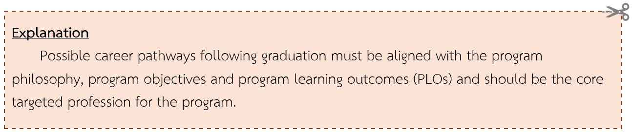

(1) …………………………………………………………………………………………….………..
(2) ………………………………………………………………………………………….…………..
(3) ………………………………………………………….………………………………………….

Part 4 Appendix

Appendix A Opinions of the External Experts and Program Responses
Appendix B Unit of Learning Descriptions
Appendix B1 Unit of Learning Descriptions : General Education / Basic Engineering / Basic Science and Mathematics
Appendix B2 Unit of Learning Descriptions of the subjects in the course
Appendix (B2.1) Unit of Learning Descriptions: Course
Appendix (B2.2) Unit of Learning Descriptions: Learning Pathways and OBEM
      - OBEM as part of a Learning Pathway
      - OBEM is not part of a Learning Pathway
appendix C Background of the Program Faculty Members and Supporting Staff
appendix C1 Background of the Program Faculty Members
appendix C2 Background of the Supporting Staff
appendix D Appointment of the Program Development/ Revision Committee
Appendix E Regulations of KMUTT on Undergraduate/ Graduate Studies
Appendix F Collaboration with other Institutions (If any)
Appendix G Course Comparison between the Former Program and the Revised Program (Only for Revised Program)
Appendix H .... Others.... (If any)

Appendix A: Opinions of the External Experts and Program Responses
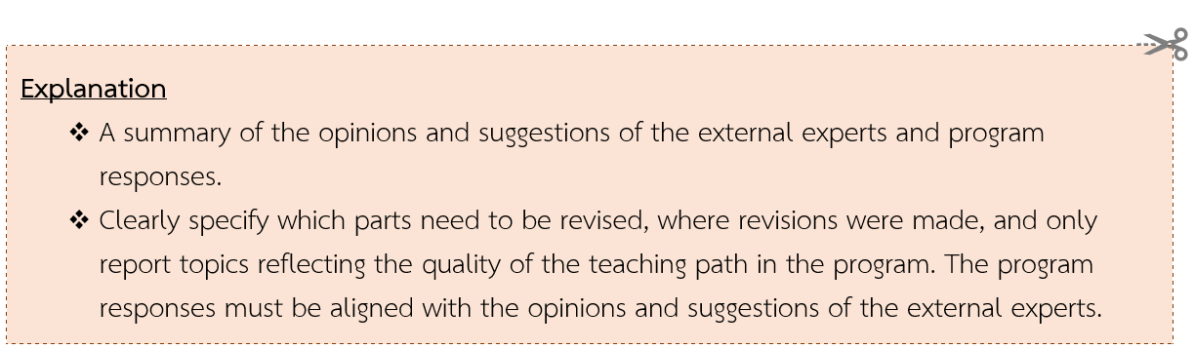

Example
Full Name: ……………………………………………..........................................................……………..
Position and/or Academic Rank: ......................................................................................
Affiliation: ………………………………...........................................................................................
Type of Expert: …Academic, Industry, Employer... (Specify the role of the experts as approved by the Academic Council)
Approves the program, but has the following suggestions:
Suggestions | Program Responses
Information which should not be included, as they are suggestions which do not reflect the quality of teaching, for example:  1. The course name for course code number xxx123 on page 23 does not match the one on page 145.  2. Many spelling errors were found. | 1. All inconsistencies have been rectified.  2. All spelling errors have been rectified.
Suggestions | Program Responses
Good examples to be followed, for example, the program should provide training on communication skills and presentation skills to students. | Courses XXX and YYY have been added to the program. These courses aim to provide all students with training in presentation skills. All courses in the program have been requested to integrate presentations as part of the course component in order to help students improve their communication skills and presentation skills.

Appendix B Unit of Learning Descriptions

Appendix B1 Unit of Learning Descriptions : General Education / Basic Engineering / Basic Science and Mathematics
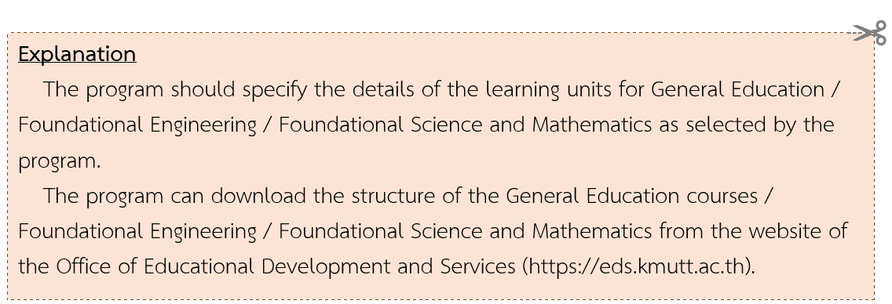

Course Code .............................................................
Course Name (Thai): .............................................................................................................
(English): .............................................................................................................

Number of Credits: ......... 3(3-0-6) .......
Category: ......Compulsory Course/Elective.............
Course Requirements (if any):
- Pre-requisite : ......... None / Yes (Specify module code and course name).......
- Co-compulsory : ......... None / Yes (Specify module code and course name).......
- Other (specify): ...............................................................................................................
................ e.g. This course/module is offered only in this program. /This course/module is available only to fourth-year students. ............................
Course Description:
(Thai): .........................................................................................................................................
(English): ....................................................................................................................................
Course Learning Outcomes (CLOs):
- .........................................................................................................
- ..........................................................................................................

Appendix B2 Unit of Learning Descriptions of the subjects in the course
Appendix (B2.1) Unit of Learning Descriptions: Course
Course Code ................MMD123..........................
Course Name (Thai): .............................................................................................................
(English): .............................................................................................................

Number of Credits: ......... 3(3-0-6) .......
Category: ......Compulsory Course/Elective.............
Course Requirements (if any):
- Pre-requisite : ......... None / Yes (Specify module code and course name).......
- Co-compulsory : ......... None / Yes (Specify module code and course name).......
- Other (specify): ...............................................................................................................
....... e.g. This course/module is offered only in this program. /This course/module is available only to fourth-year students. ............................
Course Description:
(Thai): .........................................................................................................................................
(English): ....................................................................................................................................
Course Learning Outcomes (CLOs):
- .........................................................................................................
- ..........................................................................................................

Appendix (B2.2) Unit of Learning Descriptions: Learning Pathways and OBEM
Learning Pathway 1 Name:......................................................
Learning Pathway Descriptions:
(Provide a description to introduce this Learning Pathway, including its objectives, the intended target group of learners, and the specific competencies and abilities that learners will acquire from this Learning Pathway.)
...............................................................................................................................................................................
...............................................................................................................................................................................................
Learning Outcomes of the Learning Pathway
.............Identify the overall core competencies learners will acquire after completing the pathway, which can be applied to their future workforce performance or further specialized tasks.........................................................................................................................................
……………………………………………………………………………………………………………………………………………………

This learning pathway includes the following Learning Outcomes in accordance with the Thailand Quality Framework (TQF):
(Specify keywords or a brief summary of the overall learning pathway.)
K-Knowledge: ....................................................................................................................
S-Skills: ...............................................................................................................................
E-Ethics: .............................................................................................................................
C-Characters: ....................................................................................................................
Learner Qualifications Prior to Enrollment in the Learning Pathway:
( Provide a brief description to support the learner admission process, such as educational background, profession, relevant work experience, etc., or as deemed appropriate by the Curriculum Committee.)
Learner Qualifications and Requirements in the Learning Pathway:
( Briefly describe the admission criteria, such as educational qualifications, professional background, work experience, or as determined by the Program Committee.)
...............................................................................................................................................................................................
...............................................................................................................................................................................................
The Learning Pathway consists of the following OBEM:
No. | OBEM course | Course Category | Credits
1 |  | Compulsory Course | 1(1-0-2)
2 |  | Elective Course
3
Learning Requirements: (If any)
……………………………………………………………………………………………………
Examples:
- Learners must achieve the learning outcomes of all courses within the learning pathway to be certified. Credits may be accumulated for future transfer into a degree program. However, credit transfer is subject to the specific conditions of each program and must be in accordance with university regulations.
- Learners must achieve the learning outcomes of the prerequisite courses before proceeding to subsequent courses in the learning pathway (where prerequisites are specified).
- Learners must complete the courses in the prescribed sequence within the learning pathway. / Learners may select and complete courses in any order based on their preferences.
- OBEM as part of a Learning Pathway Total of ......... OBEM
Recommendations for Defining Learning Outcomes and Rubrics
- Each OBEM course must define a single Learning Outcome at the 'Apply' level or higher according to Bloom’s Taxonomy. However, the program may specify sub-learning outcomes to enhance the clarity of assessment. Furthermore, a 5-level Rubric must be established in alignment with the designated Learning Outcome.
- To clearly measure and evaluate learner performance, Learning Outcomes must be structured as: Action Verb + Object + Qualifying Phrase. Avoid using non-observable verbs such as: 'have', 'be aware', 'know', or 'understand'.
- Define the learning assessment criteria (Rubric) using a 5-level scale. Level 3 must serve as the passing threshold in alignment with the Learning Outcome, representing the level at which learners meet the expected learning outcomes.
- All five levels of the assessment rubric should utilize the same action verb with qualifying phrases to measure the learner's competency levels. Furthermore, the rubric must be fully aligned with the Learning Outcome.
- The assessment rubric should avoid using subjective or ambiguous terms that lack clear measurability, such as 'good', 'fair', 'partially', 'mostly', or 'minimally'. Furthermore, Level 1 should not be written in a negative tone, such as by describing that the learner is completely unable to perform the task.
- Do not define rubric levels by simply climbing the Bloom’s Taxonomy hierarchy (e.g., Level 1: Remember, Level 2: Understand, Level 3: Apply, Level 4: Analyze, Level 5: Evaluate/Create). Instead, the rubric should measure different degrees of performance for the specific action verb defined in the Learning Outcome.

Course Code ....................OBE10101.................
Course Title (Thai): .............................................................................................................
(English): .........................................................................................................

Number of Credits: ......... x(x-x-x) .......

Learning Duration: ............ Hours
Course Category: o Compulsory Course o Elective Course
Course Conditions (If any):
- Prerequisite: ........ None/Yes (Please specify Course Code and Title).......
- Corequisite: ......... None/Yes (Please specify Course Code and Title).......
- Others (Specify): ...............................................................................................................
Course Description:
(Thai): .........................................................................................................................................
(English): .......................................................................................................................................
Learning Outcome :
[OBEM course must have only one Learning Outcome]
(Thai): ................................................................................................................................
(English): ........ Required for English/International programs............
Assessment Criteria (Rubrics) for OBEM course
Level | Performance Criteria
Level 1
Level 2
Level 3*
Level 4
Level 5

- OBEM is not part of a Learning Pathway Total of ......... OBEM

Course Code ....................OBE10101.................
Course Title (Thai): .............................................................................................................
(English): .........................................................................................................

Number of Credits: ......... x(x-x-x) .......

Learning Duration: ............ Hours
Course Category: o Compulsory Course o Elective Course
Course Conditions (If any):
- Prerequisite: ........ None/Yes (Please specify Course Code and Title).......
- Corequisite: ......... None/Yes (Please specify Course Code and Title).......
- Others (Specify): ...............................................................................................................
Course Description:
(Thai): .........................................................................................................................................
(English): .......................................................................................................................................
Learning Outcome:
[OBEM must have only one Learning Outcome]
(Thai): ................................................................................................................................
(English): ........ Required for English/International programs............
Assessment Criteria (Rubrics) for OBEM
Level | Performance Criteria
Level 1
Level 2
Level 3*
Level 4
Level 5

Appendix C Background of the Program Faculty Members and Supporting Staff

Appendix C1 Background of the Program Faculty Members
Name - Surname Thai ..........................................................
Name – Surname English ........................................................
- Educational Background
Year B.E. ......... Ph.D. (………………………..), University ……………...…., Thailand
Year A.D. .......... M.S. (………………………..), University of …………………., U.S.A.
Year A.D. .......... B.S. (………………………..), University of …….....…………., U.S.A.
Qualifications and Fields of Study
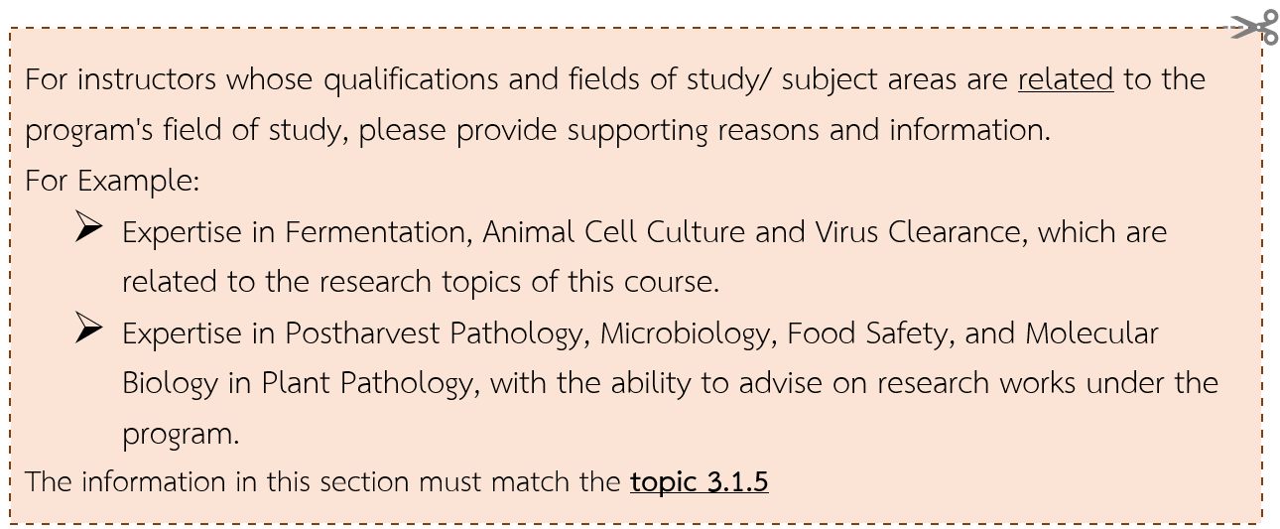
Qualifications and fields of study are matched with those of the program.
Qualifications and fields of study/ subject areas are related to the course subjects of the program (Please explain) .....................

- Academic Work for the Past Five Years

Group 1 Research (for 1.1 and 1.2 must specify which database can be searched according to the Office of the Higher Education Commission’s announcement, such as Scopus, Web of Science, etc.)
  - International journal (Weight value 1)
.................................................................................................................
  - National Journal (0.4 weight value)
.................................................................................................................
  - International Conference (0.4 Weight)
.................................................................................................................
  - National Conference (0.2 weight)
.................................................................................................................

Group 2 Academic Works in other Forms
  - Academic Works for Industry
.................................................................................................................
  - Academic Works for Teaching and Learning Development
.................................................................................................................
  - Academic Works for the Development of Public Policy
.................................................................................................................
  - Case Studies
.................................................................................................................
  - Translation Works
.................................................................................................................
  - Dictionaries, Encyclopedias, Directories, and Similar Academic Works
.................................................................................................................
  - Creative Works in Science and Technology
.................................................................................................................
  - Aesthetics and Artistic Creative Works
.................................................................................................................
  - Patents
.................................................................................................................
  - Software
.................................................................................................................

Group 3 Academic Works for Serving Society
.................................................................................................................

Group 4
4.1 Textbooks
.................................................................................................................
4.2 Books
.................................................................................................................
4.3 Academic Articles
.................................................................................................................

Guideline:
- Identify only updates of 3-5 works that are relevant to their fields of study. (excluding categories without works).
- Fill in information completely according to the principles of writing a bibliography. See the details of the manual for writing academic works according to the bibliographic format on the EDS website.
Example writing format for journal articles:
Author(s). (Year of publication). “Title of the article,” Full name of the journal. Volume (vol.), Issue or edition (No.), Pages. (Available from TCI database…)
For other formats of works, further details can be found in the manual for writing academic works.
- The specified work must be formatted and distributed in accordance with the Civil Service Commission in Higher Education Institutions.
- Works of no. 1.1-1.4 must specify which database it can be searched from as announced by the Office of the Higher Education Commission, such as Scopus, Web of Science, etc.
- Clearly separate the types of work. See the types of academic work attached to the Office of the Higher Education Commission's announcement regarding criteria and methods for considering appointments of persons to positions: Assistant Professor, Associate Professor, and Professor.
- Works presented at international and national academic conferences since B.E. 2565 (2022) must come from academic conferences organized by academic or professional associations, in accordance with the notification of the Office of the Civil Service Commission in Higher Education Institutions and must specify which entities organized the academic conference completely. In cases where there are more than ten organizing bodies, at least five primary organizers must be identified. Additionally, a cover page of the proceedings book comprising the academic articles must be attached to the work submitted.
Articles in the conference proceedings should be formatted as follows:
Author's Name. (Year of Publication). “Article Title,” Conference Name. Conference Session (if applicable), Date of Conference, Location of Conference, Page Numbers. [Conference organized by...............]

Example:
“Niticai Lueang-aram, Kusakanna Kubaha, and Rungrojt Songkhaob. (2022). “Feasibility Assessment of Repurposing Lithium-Ion Batteries from Electric Vehicles as Energy Storage Systems along with Rooftop Solar Power in Thailand,” Proceedings of Kasetsart University’s Academic Conference, 60th Session, February 21-23, 2022, Kasetsart University, Bangkhen, Bangkok, Thailand, pp. 196-204.” [Conference organized by Kasetsart University in collaboration with the Ministry of Higher Education, Science, Research and Innovation, the Ministry of Agriculture and Cooperatives, the Ministry of Education, the Ministry of Digital Economy and Society, the Office of the National Science, Research, and Innovation Policy Council, and the Prachachuen Research Network.]



3. Workload
3.1) Current Workload
- Undergraduate/graduate Workload (includes project/thesis/independent study)

Course Code | Course Name | Credit(s) | Credit Hour(s) per Academic Year (Approximately)
- Other workloads (if any)
.............................................................................................................................................................................
.............................................................................................................................................................................

3.2) Workload in this course
- Undergraduate/graduate Workload (includes project/thesis/independent study)
Course Code | Course Name | Credit(s) | Credit Hour(s) per Academic Year (Approximately)

4.Work experience/Operational experience
(for Professional Bachelor’s Degree or Operations Bachelor’s Degree program)
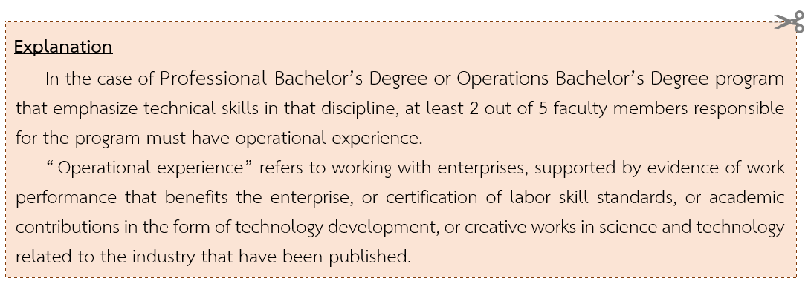
............................................................................................................................................................... ...............................................................................................................................................................

Appendix C2 Background of the Supporting Staff
Name of Supporting Staff in the Program (e.g., laboratory staff, technicians, and practical teachers)

No. | Full name | All educational Background Information | Scope of Work

Appendix D: Appointment of the Program Development/Revision Committee
(Attach this document before proposing the program for the university’s consideration)
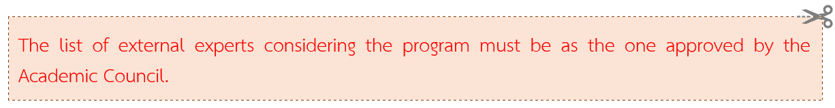

Appendix E: Regulations of KMUTT on Undergraduate / Graduate Studies
(Attach this document before proposing the program for the university’s consideration)

Appendix F: Collaboration with other Institutions (If any)
(Attach this document before proposing the program for the university’s consideration)
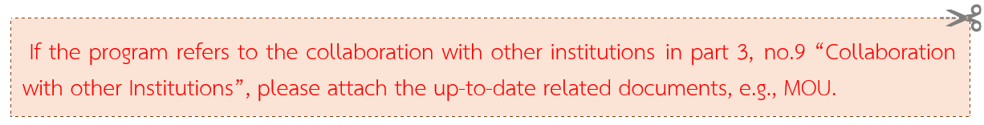

Appendix G Course Comparison between the Former Program and the Revised Program (Only for Revised Program)
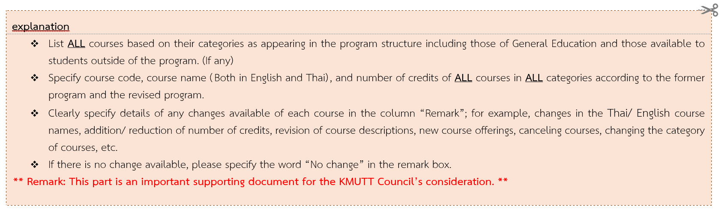

Example
The Former Program B.E. 25...... | Credit(s) | The Revised Program B.E. 25...... | Credit(s) | Details of the changes
List ALL courses (including those of General Education) based on their categories as appearing in the program structure of the former program. | X (x-x-x) | List ALL courses (including those of General Education) based on their categories as appearing in the program structure of the revised program. | X (x-x-x) | Clearly specify the changes, such as:  o Adjust course codes  o Change / Edit the Thai/English course name.  o Increase/Reduce the number of credits/credit hours  o Revisie course descriptions.  o Adjust/cancel prerequisite courses and co-requisite courses  o Open new courses.  o Cancel unnecessary courses.  o Move courses to different categories (XXXxxx)  etc.  If there is no change available, please specify the word "No change"
List courses which are available to students outside of the former program.  (If any) | X (x-x-x) | List courses which are available to students outside of the revised program.  (If any) | X (x-x-x)
DT130 Project Introduction  (การทำโครงงานเบื้องต้น) | 3 (0-6-6) | DT130 Project Introduction  (การทำโครงงานเบื้องต้น) | 4 (0-8-4) | - Increase the number of credits.  - Move to the course category No. B.5) Project and Fieldwork Experience.
INA 211 Color, Materials and Presentation  (สี วัสดุและการแสดงภาพทางสถาปัตยกรรมภายใน) | 3 (1-4-6) | INA 21101 Introduction of Color Theory and Usability  (ความรู้เบื้องต้นเกี่ยวกับทฤษฎีและการใช้งานสี) | 1 (1-0-2) | - Revise/Update the course content and improve the teaching and learning approaches.
 |  | INA 21102 Introduction of Material Theory and Usability  (ความรู้เบื้องต้นเกี่ยวกับทฤษฎีและการใช้งานวัสดุทางสถาปัตยกรรมภายใน) | 1 (0-2-2)
 |  | INA 21103 Color and Material Application in Interior Architecture  (การประยุกต์ใช้สีและวัสดุในงานสถาปัตยกรรมภายใน) | 1 (0-2-2)

